Table of Contents

Title and Abstract 2

Genetic algorithm and Memetic algorithm 3

Genetic algorithm 3

Memetic algorithm 3

Baldwinian effect and Lamarckian evolution 4

Contribution of this work 5

Methods 5

Fitness function 5

Steady-state Genetic Algorithm 9

Crossover and Mutation operators of SSGA 11

Baldwin algorithm and Lamarck algorithm 12

Local search procedure 14

Results 15

Best 20 parameter combinations 15

Results of Experiments 16

Percentage of finding the global optimal value 16

Improvements between SSGA and Baldwin, Lamarck algorithms 18

Convergence analysis 19

Conclusion 28

Reference 29

# 

# Title and Abstract

**Title**: Comparing the Lamarckian and Baldwinian Approaches in Memetic Optimization

**Abstract**: Memetic optimization (MO) combines local and global search in optimization in non-monotonic, ‘rugged’ search spaces. In particular, MO extends genetic optimization, where global search is implemented via the crossover operator and local search is performed as random mutation. MO uses more elaborate techniques to implement local search and to combine it with its global counterpart.

This study is set to compare two ways of memetic optimization: one motivated by the Baldwinian effect, while the other by the Lamarckian theory of evolution.

Both the Baldwinian and Lamarckian theory suggest that behaviors of individuals are not only passed on to offspring by crossover and mutation, but also through lifetime learning. In Baldwin approach, learned behaviors affect the mapping of genotypes to phenotypes, which ultimately results in changes to the fitness landscape. In Lamarck approach, not only will the learned behaviors affect the fitness landscape in the same way as the former does, but they will also be passed on to offspring through phenotypes. Whilst the biological plausibility of these perspectives is questionable, they offer a valuable structure for constructing memetic optimization algorithms.

Before exploring Lamarckian and Baldwinian approaches, a baseline framework where offspring can only inherit the characteristics of the parent through crossover and mutation (i.e., genetic optimization) is considered as a global optimization problem. Based on the baseline framework, we develop various implementations of the Lamarckian and Baldwinian approaches exploring several local search procedures to study the potential contributions of the studied approaches. Our experiments will be performed on the CEC-BC-2017 test functions for optimization.

**Keywords**: Baldwinian evolution; Lamarckian evolution; Memetic optimization; Fitness landscape; Learning; CEC-BC-2017.

# Genetic algorithm and Memetic algorithm

## Genetic algorithm

Genetic Algorithm (GA) has become one of the critical methods behind solvers capable of addressing large-scale real-world optimization problems. It has been positively explored in research institutes as well as being actively employed in industry. GA is a population-based stochastic algorithm originated from Darwinian theory of evolution, belonging to the broader category of Evolutionary Algorithms. It consists of three principal bio-inspired operators: selection, crossover, and mutation [1-3]. Inspired by that only superior individuals in the population have the chance to produce offspring and pass on their genes, selection operator only selects the fittest individuals, and this selectivity lays the most important foundation for GA to be applied to solve optimization problems. Owing to the contribution of the selection operator, GA always maintains the best solution in each generation and evolves towards better solutions. Part of selection operators such as local selection, fuzzy selection, fitness uniform selection, linear rank selection, steady-state reproduction can be found in [4-8]. Crossover operator allows two parents to swap their genes with a certain probability, thereby producing a solution between two points [1-3]. A variety of ways to implement crossover operators such as uniform crossover, half uniform crossover, three parent’s crossover, partially matched crossover, cycle crossover, and order crossover are introduced in the literature [9-14]. Different from crossover, mutation operator randomly alters some genes of an individual by chance, resulting in the production of another new solution, which improves the diversity of the whole population [1-3]. Some mutation operators such as Gaussian, shrink, supervised mutation, uniqueness mutation, varying probability of mutation can be accessed in [15-19].

As mentioned earlier, only individuals that are adapted to their environment will survive. How well an individual is adapted to its environment is determined according to a fitness function, i.e., the objective function. Each individual’s genotype is a solution to the fitness function. Therefore, the fitness value of each individual is the result of the calculation performed by bringing the genotype into the fitness function. A Fitness landscape is applied to help visualize the relative locations between genotypes and a fitness function. A fitness landscape is a (N+1)-dimensional view of a fitness function while a genotype is a N-dimensional point. The height of a fitness landscape represents fitness value of an individual [20-21].

Figure 1(left part) presents the process of a simple genetic algorithm. The evolution starts from a population with randomly generated individuals. GA measures the fitness value of each individual and selects the most adapted individuals, then creates new offspring by crossover and mutation with a certain probability. New individuals will join the population and participate in the next iteration. After continuous iteration, GA moves towards better population, but it is not guaranteed to find the global optima every time, depending on multiple factors such as the number of iterations and the complexity of the objective function.

## Memetic algorithm

With the influence of R. Dawkins' notion of 'memes' [22], Pablo Moscato first introduced memetic algorithm (MA) in 1989 and he proposed that memetic algorithm is similar to a mixed population-based genetic algorithm combined with an individual’s learning procedure that enables local fine-tuning [23]. Broadly speaking, MA is an extension of GA by introducing local search heuristics into the framework of stochastic global search techniques [24-26], which decreases the probability of the premature convergence of GA to a certain level [26-27]. Local search procedure (LSP) is a type of optimization method that explores a small space nearby the current solution and replaces the current solution by a better one if exists [28].

In searching for the optimal value of a fitness function, crossover operator gives individuals the ability to jump across the landscape of a fitness (objective) function while mutation operator enables individuals to explore local environment in fitness. MA further reinforces local search on the basis of mutation.

Figure 1(right part) presents one way of implementing a simple memetic algorithm.

In genetic algorithms, each individual has its own genotype, which is a solution to an objective function. With the help of a local optimizer, MA generates a new solution in the vicinity of the fitness landscape where the genotype is located. The better of genotype and the new solution will be involved in the later operations.

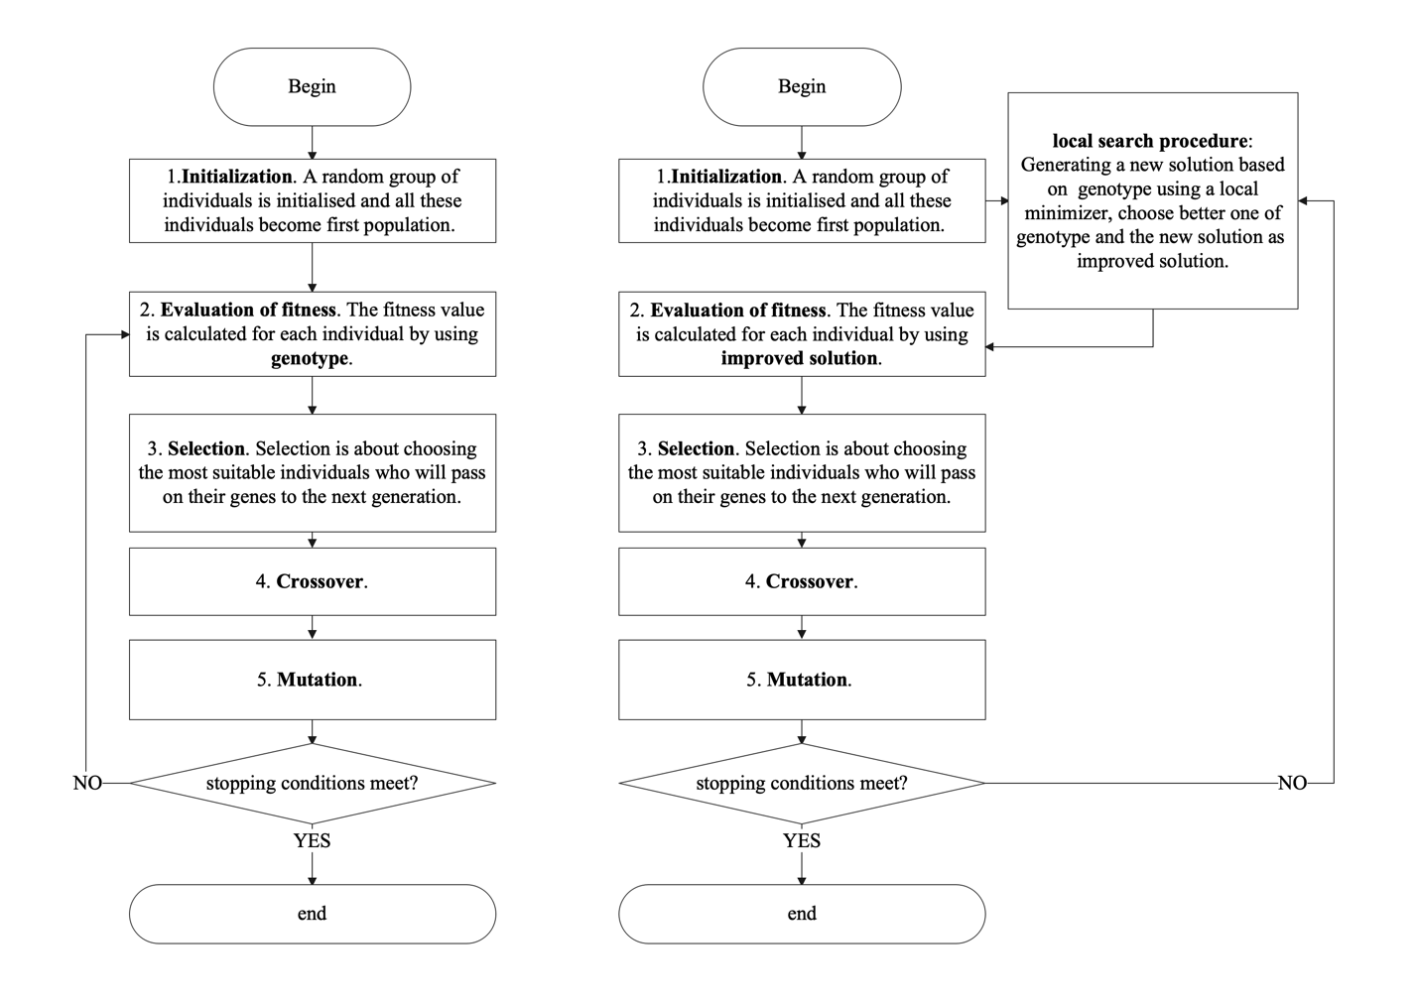

Figure Flowchart of Genetic algorithm(left) and Memetic algorithm(right)

While in principle the enhanced exploitation of candidate solutions by adding a local search procedure should lead to an improvement of the algorithm, this is not always the case [24]. For example, if the population is almost converged and has reached a local optimum, then no local search procedure will find a better solution than the current one, and in this case, it simply plays no role. Our expectation is that memetic algorithms will create collaborative effects that usefully bridge local and global search.

## Baldwinian effect and Lamarckian evolution

The Baldwinian effect and Lamarckian evolution are both memetic algorithms which focus on how individual’s lifetime learning affects the evolutionary direction [29-35]. Individuals can develop a phenotype based on its own genotype through lifetime learning, this ability allows individuals to do some local exploration around the current location (i.e., where the genotype is located). In computation, genotypes and phenotypes are typically high-dimensional vectors while their biological significance can be conceived as the DNA of an individual and the physical body of an individual [36].

Both the Baldwinian effect and Lamarckian evolution suggest that behaviors of individuals are not only passed on to offspring by crossover and mutation, but also through lifetime learning. In Baldwin approach, learned behaviors affect the mapping of genotypes to phenotypes, which ultimately results in changes to the fitness landscape. In Lamarck approach, not only will the learned behaviors affect the fitness landscape in the same way as the former does, but they will also be passed on to offspring through phenotypes. Whilst the biological plausibility of these perspectives is questionable, they offer a valuable structure for constructing memetic optimization algorithms [34-38].

For instance, a genotype is a point on the fitness landscape and the height of the point represents the fitness value of an individual. Our goal is to find the global maximum of the fitness function, which means that a higher fitness value for an individual corresponds to a higher position on the fitness landscape. If the fitness value of the phenotype is higher, then the fitness value of this individual is replaced by the fitness value of the phenotype. The mapping of genotype to phenotype can be appreciated as a lifelong learning outcome for the individual, which leads to a change on the fitness landscape.

The difference is that phenotype is not inherited to the offspring in Baldwin approach, but it can be in Lamarck approach. Both approaches have their strengths and weaknesses, and it is difficult to judge which is better than the other. Baldwin approach has been found to perform better than Lamarck approach in dynamic environments [39-40], while Lamarck approach is found to be better at solving optimization problems of convex functions [41-42].

## Contribution of this work

We offer two versions of memetic algorithms: one motivated by the Baldwinian effect, while the other by the Lamarckian theory of evolution, namely as Baldwin algorithm and Lamarck algorithm, respectively. Before implementing the two algorithms, we create a baseline called Steady-state genetic algorithm (SSGA) as global optimization, then we develop Baldwin and Lamarck algorithms by adding local search procedures into SSGA as a combination of memetic optimization and global optimization. The first goal of this paper is to evaluate the effectiveness of local search procedures in Baldwin and Lamarck algorithms. The second goal of this paper is to compare the performance of Baldwin and Lamarck algorithms by using benchmark functions CEC-BC-2017 [43]. It includes unimodal functions, multimodal functions, hybrid functions and composition functions with high dimensions, etc., which can be used to universally assess proposed Baldwin and Lamarck algorithms. This is what makes this study unique.

# Methods

## Fitness function

CEC-BC-2017 contains 23 benchmark functions with different characteristics and levels of difficulty, which can be used to evaluate the performance of new algorithms. Table 1 shows 23 test functions with details. The header of Table 1 includes: function, dimension, domain, and the optimal. The number of dimensions varies from 2 to 50. Each function has a domain, which explains the upper and lower bounds of the function. A global optimal value is the smallest value that a function can achieve within its domain.

Figure 2 shows the first two-dimensional view of fitness landscape for part of CEC-BC-2017 benchmark functions, considering the layout, two-dimensional view of fitness landscape for all functions is not shown, but one can get a two-dimensional view of fitness landscape for all the functions in the appendix. Figure 2 has 10 subpictures, and each subpicture is a fitness landscape view of a fitness function in two dimensions with a title specifies function’s name. Of all 23 functions, the smallest number of dimensions is 2. For normal high dimensional functions, the first and second dimensions are picked up for generating this view. For high-dimensional and dimension-fixed functions, such as F15, F19, F20, F21, F21, F22 and F23, the first and second dimensions are picked while other dimensions still exist, but values of other dimensions are set to zero.

Table CEC-BC-2017 benchmark functions

|  |  |  |  |
| --- | --- | --- | --- |
| Function | Dim | Range | Optimal |
| $$F1=\sum_{i=1}^{50}{ }x_{i}^{2}$$ | 50 | [-100,100] | 0 |
|  | 50 | [-100,100] | 0 |
| $$F3=\sum_{i=1}^{50}{ }\left(\sum_{i=1}^{50}{ }={\left(x_{i}\right)}^{2}\right)$$ | 50 | [-100,100] | 0 |
|  | 50 | [-100,100] | 0 |
| $$F5=\sum_{i=1}^{49}{ }\left(100{\left(x_{i+1}-x_{i}^{2}\right)}^{2}+{\left(x_{i}-1\right)}^{2}\right)$$ | 50 | [-30,30] | 0 |
| $$F6=\sum_{i=1}^{49}{ }{\left(x_{i}+0.5\right)}^{2}$$ | 50 | [-100,100] | 0 |
| $$F7=\sum_{i=1}^{50}{ }\left(ix_{i}^{4}\right)$$ | 50 | [-1.28,1.28] | 0 |
|  | 50 | [-500,500] | -418.98xd |
| $$F9=\sum_{i=1}^{50}{ }\left(x_{i}^{2}-10\cos\left(2πx_{i}\right)+10\right)$$ | 50 | [-5.12,5.12] | 0 |
| $$F10=-20exp⁡\left(-0.2\sqrt{0.02\sum_{i=1}^{50}{ }x_{i}^{2}}\right)-exp⁡\left(0.02\sum_{i=1}^{50}{ }cos⁡2πx_{i}\right)+20+e$$ | 50 | [-32,32] | 0 |
| $$F11=\frac{1}{4000}\sum_{i=1}^{50}{ }x_{i}^{2}-\prod_{i=1}^{50}{ }cos⁡\frac{x_{i}}{\sqrt{i}}+1$$ | 50 | [-600,600] | 0 |
| $$F12=\frac{π}{50}\left(10\sin^{2}\left(πy_{1}\right)+\sum_{i=1}^{49}{ }{\left(y_{i}-1\right)}^{2}\left(1+10\sin^{2}⁡πy_{i+1}+{\left(y_{50}-1\right)}^{2}\right)+\sum_{i=1}^{50}{ }u\left(x_{i},10,100,4\right)\right.$$ | 50 | [-50,50] | 0 |
| $$F13=0.1\left(\sin^{2}\left(3πx_{1}\right)+\sum_{i=1}^{49}{ }{\left(x_{i}-1\right)}^{2}\left(1+\sin^{2}\left(3πx_{i}+1\right)\right)+{\left(x_{50}-1\right)}^{2}\left(1+\sin^{2}\left(2πx_{50}\right)\right)\right)$$ $$+\sum_{i=1}^{50}{ }u\left(x_{i},5,100,4\right)$$ | 50 | [-50,50] | 0 |
| a = [[-32, -16, 0, 16, 32, -32, -16, 0, 16, 32, -32, -16, 0, 16, 32, -32, -16, 0, 16, 32, -32, -16, 0, 16, 32],  [-32, -32, -32, -32, -32, -16, -16, -16, -16, -16, 0, 0, 0, 0, 0, 16, 16, 16, 16, 16, 32, 32, 32, 32, 32]] $$F14={\left(\frac{1}{500}+\sum_{j=1}^{25}{ }\frac{1}{j+\sum_{i=1}^{2}{ }{\left(x_{i}-a_{ij}\right)}^{6}}\right)}^{-1}$$ | 2 | [-65,65] | 1 |
| a = [.1957, .1947, .1735, .16, .0844, .0627, .0456, .0342, .0323, .0235, .0246];  b = [.25, .5, 1, 2, 4, 6, 8, 10, 12, 14, 16]; b=1. /b $$F15=\sum_{i=1}^{11}{ }{\left(a_{i}-\frac{x_{1}\left(b_{i}^{2}+b_{i}x_{2}\right)}{b_{i}^{2}+b_{i}x_{3}+x_{4}}\right)}^{2}$$ | 4 | [-5, -5] | 0.0003 |
| $$F16=4x_{1}^{2}-2.1x_{1}^{4}+\frac{1}{3}x_{1}^{6}+x_{1}x_{2}-4x_{2}^{2}+4x_{2}^{4}$$ | 2 | [-5, -5] | -1.0316 |
| $$F17={\left(x_{2}-\frac{5.1}{4π^{2}}x_{1}^{2}+\frac{5}{π}x_{1}-6\right)}^{2}+10\left(1-\frac{1}{8π}\right)cos⁡\left(x_{1}\right)+10$$ | 2 | [-5, -5] | 0.398 |
| $$\begin{aligned}&F18=\left[1+{\left(x_{1}+x_{2}+1\right)}^{2}\left(19-14x_{1}+3x_{1}^{2}-14x_{2}+6x_{1}x_{2}+3x_{2}^{2}\right)\right]× \\ \left[30+{\left(2x_{1}-3x_{2}\right)}^{2}×\left.\left(18-32x_{1}+12x_{1}^{2}+48x_{2}-36x_{1}x_{2}+27x_{2}^{2}\right)\right]\right. \\ &\end{aligned}$$ | 2 | [-2, -2] | 3 |
| a = [[3, 10, 30], [.1, 10, 35], [3, 10, 30], [.1, 10, 35]]; c = [1, 1.2, 3, 3.2]  p = [[.3689, .117, .2673], [.4699, .4387, .747],  [.1091, .8732, .5547], [.03815, .5743, .8828]] $$F19=-\sum_{i=1}^{4}{ }\left(c_{i}exp⁡\left(-\sum_{j=1}^{3}{ }a_{ij}{\left(x_{j}-p_{ij}\right)}^{2}\right)\right.$$ | 3 | [0,1] | -3.86 |
| a = [[10, 3, 17, 3.5, 1.7, 8], [.05, 10, 17, .1, 8, 14], [3, 3.5, 1.7, 10, 17, 8], [17, 8, .05, 10, .1, 14]];  c = [1, 1.2, 3, 3.2]  p = [[.1312, .1696, .5569, .0124, .8283, .5886], [.2329, .4135, .8307, .3736, .1004, .9991],  [.2348, .1415, .3522, .2883, .3047, .6650], [.4047, .8828, .8732, .5743, .1091, .0381]] $$F20=-\sum_{i=1}^{4}{ }\left(c_{i}exp⁡\left(-\sum_{j=1}^{6}{ }a_{ij}{\left(x_{j}-p_{ij}\right)}^{2}\right)\right.$$ | 6 | [0,1] | -3.32 |
| a = [[4, 4, 4, 4], [1, 1, 1, 1], [8, 8, 8, 8], [6, 6, 6, 6], [3, 7, 3, 7]]; c = [.1, .2, .2, .4, .4] $$F21=-\sum_{i=1}^{5}{ }{\left(\left(X-a_{i}\right){\left(X-a_{i}\right)}^{T}+c_{i}\right)}^{-1}$$ | 4 | [0,10] | -10.1532 |
| a = [[4, 4, 4, 4], [1, 1, 1, 1], [8, 8, 8, 8], [6, 6, 6, 6], [3, 7, 3, 7], [2, 9, 2, 9], [5, 5, 3, 3]];  c = [.1, .2, .2, .4, .4, .6, .3] $$F22=-\sum_{i=1}^{7}{ }{\left(\left(X-a_{i}\right){\left(X-a_{i}\right)}^{T}+c_{i}\right)}^{-1}$$ | 4 | [0,10] | -10.4028 |
| a = [[4, 4, 4, 4], [1, 1, 1, 1], [8, 8, 8, 8], [6, 6, 6, 6], [3, 7, 3, 7],  [2, 9, 2, 9], [5, 5, 3, 3], [8, 1, 8, 1], [6, 2, 6, 2], [7, 3.6, 7, 3.6]]  c = [.1, .2, .2, .4, .4, .6, .3, .7, .5, .5] $$F23=-\sum_{i=1}^{10}{ }{\left(\left(X-a_{i}\right){\left(X-a_{i}\right)}^{T}+c_{i}\right)}^{-1}$$ | 4 | [0,10] | -10.5363 |
| $$U(x,a,k,m)=k\left((x-a)^{m}\right)(x>a)+k\left((-x-a)^{m}\right)(x<(-a))$$ | | | |

Figure two-dimensional view for part of test functions

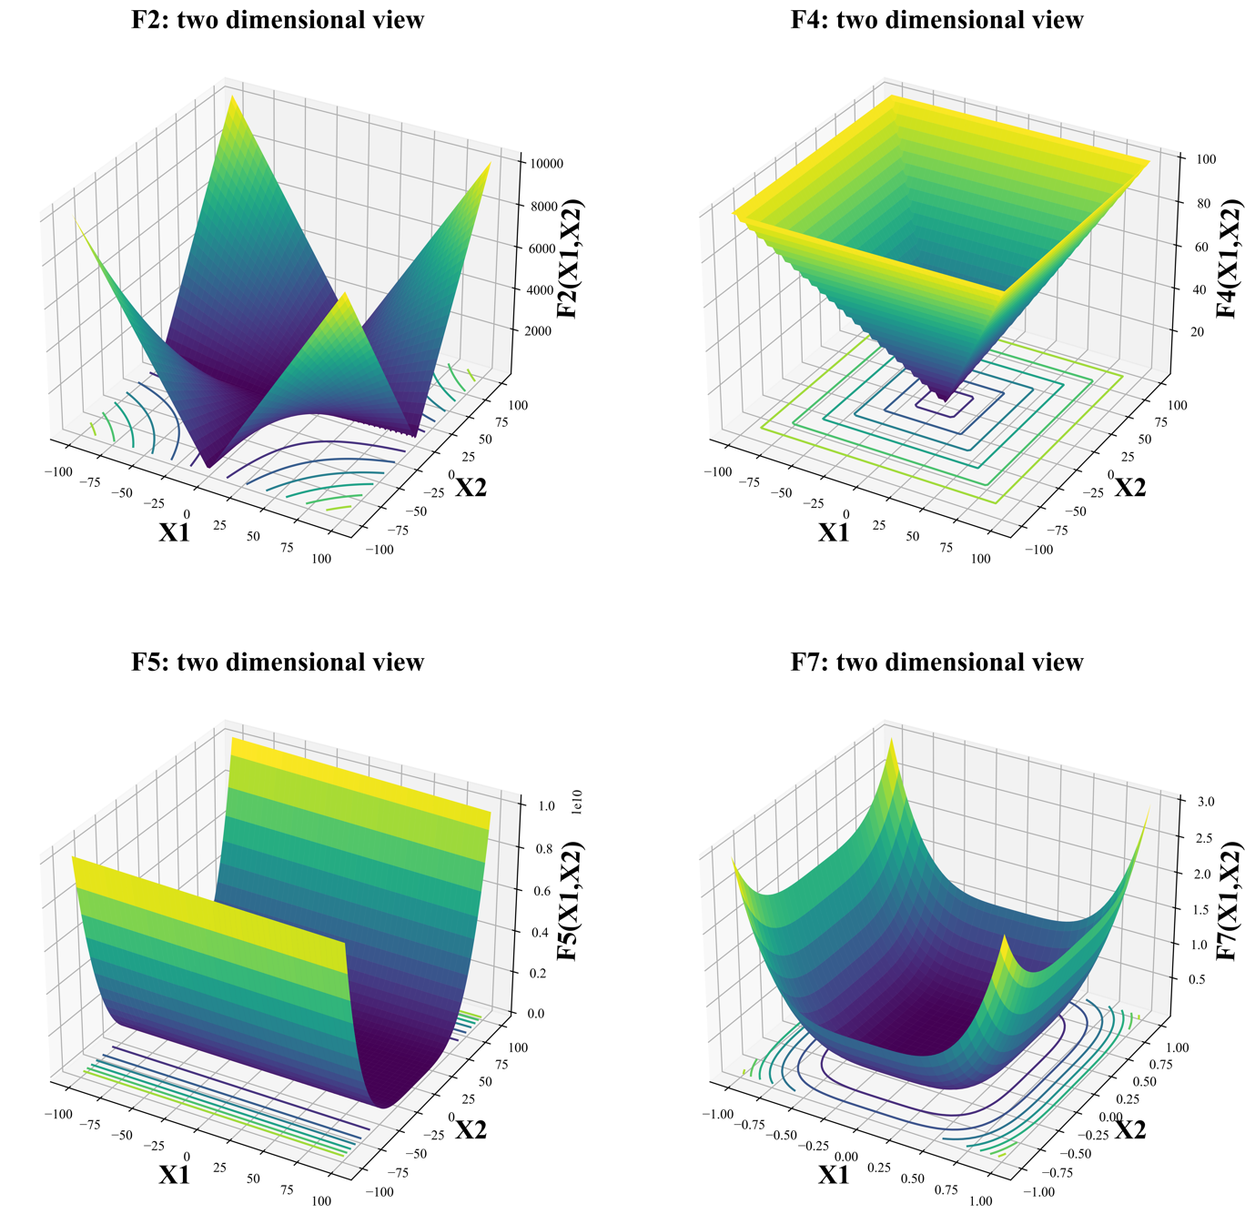

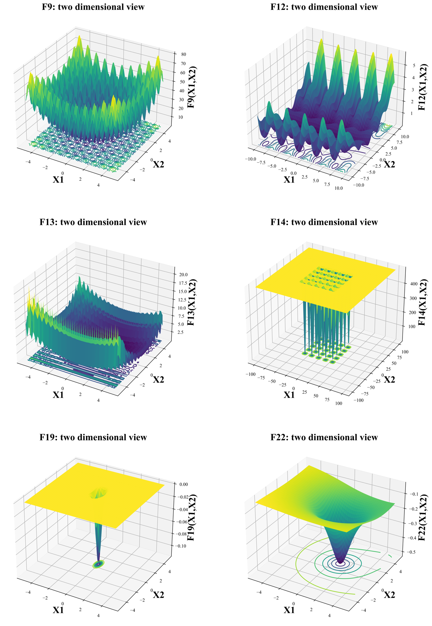

## Steady-state Genetic Algorithm

Steady-state genetic algorithm (SSGA) is implemented as a baseline framework in order to demonstrate the progress and improvements which Lamarckian and Baldwinian approaches provide. SSGA maintains a stable population size by generating only one new offspring based on the best individual in the population, while discarding the least adapted individual. The individual holding the lowest position in the fitness landscape is defined as the best individual, as our goal is to find the global minimum. In contrast, the individuals who are least adapted to the environment have the highest position. For all individuals in SSGA, genotypes and phenotypes are vectors of equal dimensions and equal values at corresponding positions in every test function of CEC-BC-2017. Fitness value of an individual is computed based on its phenotype. The genotypes of the primordial populations are randomly created with every gene located within the domain of a test function.

Figure 3 illustrates the flowchart of the SSGA algorithm. SSGA primarily consists of the following steps: (1) initialization of the population based on the parameter combination; (2) evaluation of the fitness value and similarity for the population; (3) checking stopping conditions;(4) selection of parents eligible to produce offspring and extinction of ineligible individuals; (5) crossover operation; (6) mutation operation; (7) insertion of new individuals into the population and begin execution of next iteration.

Figure Flowchart of SSGA

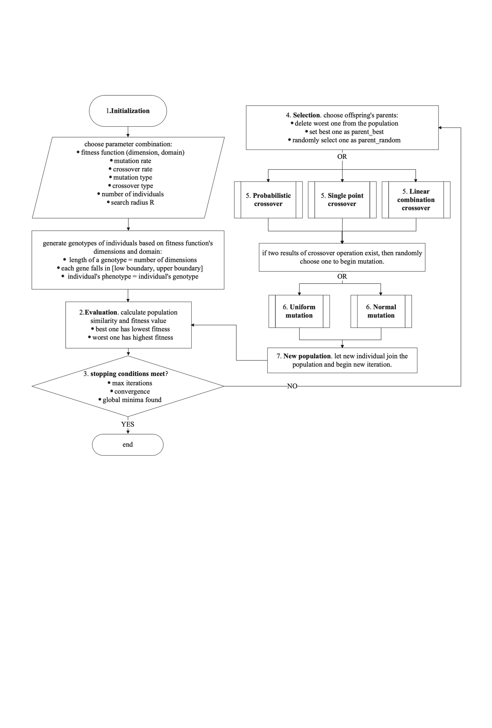

Stopping Criteria is generally organized as: (1) max number of iterations is reached; (2) a satisfactory fitness value of objective function has been found; (3) the similarity of populations is less than a pre-defined threshold for certain number of continuous iterations.

The following are the parameters of the SSGA algorithm. The maximum number of iterations is $Max_{iter}$, terminate the program when $Max_{iter}$ is reached. Convergence tolerance $Tol$ is another stopping condition. If the Euclidean similarity of whole population is less than $Tol$ in $N$ continuous iterations, then terminate the program. Alternatively, if the fitness value of the best individual minus global minima $opt is less than threshold θ$, terminate the program. In addition, search radius $R$ is a parameter that controls the range of the mutation.

**Parameters for SSGA**

**Input**: parameter combination

1. max iterations $Max_{iter}$
2. convergence tolerance $Tol$ and $N$
3. fitness function $F$, number of dimensions of is domain of is [,]
4. mutation rate $γ$, crossover rate $δ$
5. mutation type $M_{t},$ crossover type $C_{t}$
6. number of individuals $β$
7. search radius $R$
8. global minima $opt$ and threshold $θ$

**Output**: best solution $X$

The following **Pseudocode1** shows pseudo-code of SSGA.

**PseudoCode1**

**// (1) initialization of the population based on the parameter combination**

Randomly generate $β$ feasible genotypes $g$ of individuals based on $F$

Create phenotypes $p$ of individuals where $p_{i}$ = $g_{i}$

Save all the individuals in the population $Pop$

Set iteration $iter$ = 1

**// (2) evaluation**

**// (2.1) evaluation of the fitness value**

For $k=1$ to $β$ do:

Calculate $F_{p}^{k}$ fitness value for an individual $k$ using its phenotype $p$

end

Sort all the $F_{p}^{k}$ in an ascending order and change order of individuals' location in $Pop$ accordingly

Best individual has smallest fitness value $F_{p}^{k=1}$ while worst individual has the largest fitness value $F_{p}^{k=β}$

Save best solution of this generation $iter_{best}$ in iteration list $Iter list$

**// (2.2) evaluation of similarity for the population**

For $k=2$ to $β$ do:

calculate Euclidean similarity $S^{k}$ between best individual and individual $k$

end

Sum all the $S^{k}$ and save it as $iter_{similarity}$ in similarity list $Similarity list$

**// (3)** **checking stopping conditions**

If stopping conditions meet:

output $X$ minimum of best solution in all iterations

else:

continue next step

**// (4) selection of parents eligible to produce offspring and extinction of ineligible individuals**

Set best individual as best parent $B_{parent}$

Delete the worst individual from $Pop$

Randomly choose another parent as $R_{parent}$ from $Pop$

**// (5) crossover operation**

If crossover type $C_{t}$ = "Probabilistic Crossover":

do Probabilistic Crossover (crossover rate $δ$, $B_{parent}$, $R_{parent}$)

end

If crossover type $C_{t}$ = "Single point Crossover":

do Single point Crossover (crossover rate $δ$, $B_{parent}$, $R_{parent}$)

end

If crossover type $C_{t}$ = "Linear combination Crossover":

do Linear combination Crossover (crossover rate $δ$, $B_{parent}$, $R_{parent}$)

end

**// (6) mutation operation**

If mutation type $M_{t}$ = "Uniform mutation":

do Uniform mutation (mutation rate $γ$,search radius $R$, crossover result, domain of $F$ is [- $F_{low}$,- $F_{upper}$])

end

If mutation type $M_{t}$ = "Normal mutation":

do Normal mutation (mutation rate $γ$,search radius $R$, crossover result, domain of $F$ is [- $F_{low}$,- $F_{upper}$])

end

**// (7) insertion of new individuals into the population**

Calculate the fitness value for this new individual $F_{p}^{new}$ based on its phenotype

Insert $F_{p}^{new}$ in fitness list and insert this new individual in $Pop$ without breaking the ascending order

$iter$ = $iter+1$

Save best solution of this generation $iter_{best}$ in iteration list $Iter list$

Repeat (2.2) (3) (4) (5) (6) (7)

### Crossover and Mutation operators of SSGA

Three kinds of crossover operators are implemented in SSGA in this paper.

1. Single point Crossover

Given crossover rate $δ$, first generate a random probability $σ$, if $σ$ < $δ$, then begin the procedure of crossover operation, otherwise randomly choose one of the two parents as the result of crossover.

Figure 4 illustrates the single point crossover process, with the best parent in green and the random parent in red. The process of single point crossover is to select a random crossover point and then swap the best parent and the random parent for all the genes following that point.

Figure single point crossover

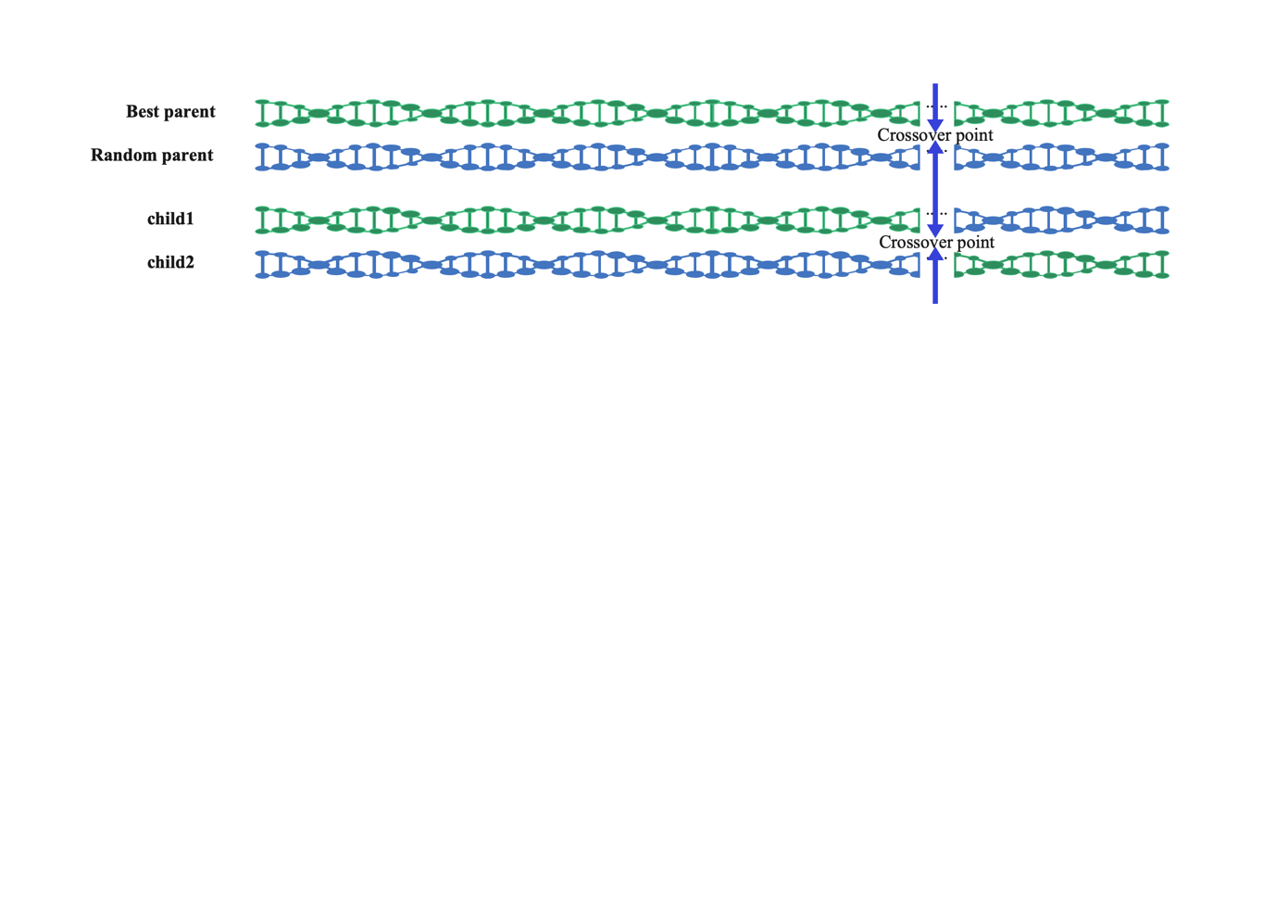

Given crossover rate $δ$, best parent $B_{parent}$, random parent $R_{parent}$, and number of fitness function’s dimensions *N*, generate a positive integer $k$ ($k<N$):

$$C_{child1}^{i}=\left\{\begin{aligned}B_{parent}^{i}, &i≤k \\ R_{parent}^{i}, &i>k\end{aligned}\right. \\ C_{child2}^{i}=\left\{\begin{aligned}R_{parent}^{i}, & i≤k \\ B_{parent}^{i}, & i>k\end{aligned}\right.$$

*Where $i ∈ 1,2,3,...N$, $i$* represents one location of a phenotype. Randomly select child1 or child2 to participate in the mutation operation afterwards.

1. Probability Crossover

Given crossover rate $δ$, best parent $B_{parent}$, random parent $R_{parent}$, and number of fitness function’s dimensions *N*, for each gene of child, the probability of getting the best parent's gene is the same as crossover rate $δ$ while the probability of inheriting a gene from a random parent is 1- $δ$. $P$ represents probability.

$$P(C_{child}^{i}=B_{parent}^{i})=δ \\ P(C_{child}^{i}=R_{parent}^{i})=1-δ$$

*Where $i ∈ 1,2,3,...N$, $i$* represents one location of a phenotype.

1. Linear combination Crossover

Given crossover rate $δ$, best parent $B_{parent}$, random parent $R_{parent}$, and number of fitness function’s dimensions *N*, the child always inherits the characteristics of two parents. $i$ represents one location of a phenotype.

$C_{child}^{i}=B_{parent}^{i}* δ + R_{parent}^{i}* (1-δ)$*where $i ∈ 1,2,3,...N$.*

Two kinds of mutation operators are implemented as following:

1. Uniform mutation

The probability density function of the continuous uniform distribution is:

$$f\left(x\right)=\left\{\begin{matrix}\frac{1}{b-a} & \text{ for }a≤x≤b \\ 0 & \text{ for }x<a\text{ or }x>b\end{matrix}\right.$$

The lower boundary and upper boundary for variable $x$ is $a$ and $b$. More specifically, $-a=b=3*R*\left(F_{upper}-F_{low}\right)$ where $F_{upper}$ and $F_{low}$ represent the upper and lower bounds of the fitness function respectively.

Given mutation rate $γ$ and result of crossover, for each value in the result of crossover, generate a random probability $σ$, if $σ$ < $δ$, then plus a variable $x$ generated by uniform distribution, otherwise remain the same.

1. Normal mutation

The probability density function of the continuous normal distribution is:

$$f\left(x\right)=\frac{1}{σ\sqrt{2}}e^{-\frac{1}{2}{\left(\frac{x-μ}{σ}\right)}^{2}}$$

$x$ = value of the variable

$μ=$ the mean = 0

$σ=$ the standard deviation = $R*\left(F_{upper}-F_{low}\right)$

Given mutation rate $γ$ and result of crossover, for each value in the result of crossover, generate a random probability $σ$, if $σ$ < $δ$, then plus a variable $x$ generated by normal distribution, otherwise remain the same.

## Baldwin algorithm and Lamarck algorithm

The difference between the Baldwin and Lamarck algorithm and SSGA is that they are combinations of memetic optimization and genetic optimization while SSGA is considered as global optimization. Compared to the SSGA, a local search procedure is additionally employed in the framework of the Baldwin and Lamarck algorithm. As mentioned before, each individual’s genotype is a solution to an objective function. The local search procedure is designed to explore the neighborhood environment where genotype is located and try to find a better solution, which is defined as phenotype in this paper. The improvement between genotype and phenotype can be interpreted as the result of a lifelong learning effort.

In Baldwin approach, the learned results of an individual are not directly passed on to the next generation, but rather the ability to find a better solution in their own vicinity. In other words, although it is phenotypes that are involved in fitness evaluation, what is involved in the computation of crossover and mutation are genotypes.

In Lamarck approach, individuals' learning also influence the mapping of genotype and phenotype, which is consistent with the Baldwin approach. From an individual's perspective, learning will put one in a more advantageous position on the fitness landscape. More importantly, the results of individual learning can be passed on directly to future generations as a legacy. In other words, the phenotype is not limited to fitness evaluation, but is also engaged in subsequent crossover and mutation operations.

Figure 5 presents a flow chart of the Baldwin and Lamarck algorithm. As one can see, there is an additional local search procedure compared to SSGA. The difference between the Baldwin and Lamarck algorithms is whether the parents' genotypes or phenotypes are used to produce offspring. They are the same as SSGA except for the additional local search procedure and the ingredients of crossover operation.

Figure Flowchart for Baldwin and Lamarck

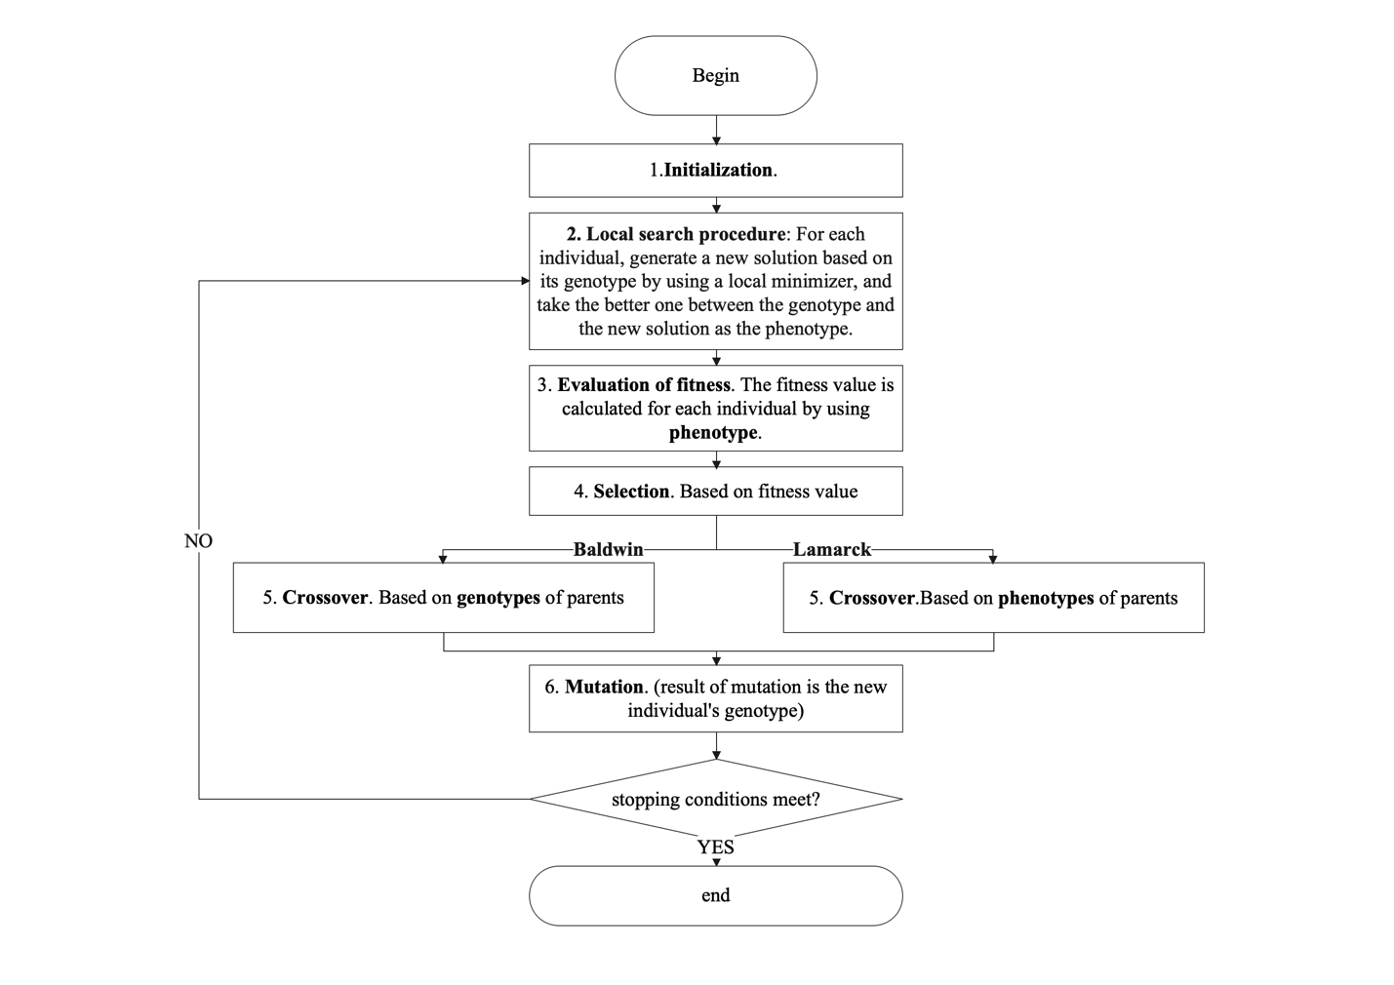

The following are the parameters of the Baldwin and Lamarck algorithm.

**Parameters for Baldwin and Lamarck algorithm**

**Input**: parameter combination

1. max iterations $Max_{iter}$
2. convergence tolerance $Tol$ and $N$
3. fitness function $F$,number of dimensions of is domain of is [-,-]
4. mutation rate $γ ,$ crossover rate $δ$
5. mutation type $M_{t} ,$ crossover type $C_{t}$
6. number of individuals $β$
7. search radius $R$
8. global minima $opt$ and threshold $θ$
9. local search rate $α$
10. local search type $LS_{t}$
11. number of local search solutions $W$
12. mode $Baldwin$ or $Lamarck$

**Output**: best solution $X$

The following **Pseudocode2** shows pseudo-code of Baldwin and Lamarck algorithm. Compared to SSGA, Baldwin and Lamarck algorithm algorithms have an additional local search procedure and a slight difference in the crossover operation, but the rest is the same as SSGA, so no repeat explanation will be given here.

**PseudoCode2**

(1)initialization of the population (number of individuals $β$, number of dimensions of $F$, domain of $F$ is [$F_{low}$,- $F_{upper}$])

Save all the individuals in the population $Pop$

**(2) local search procedure** (local search rate $α$, local search type $LS_{t}$, number of local search solutions $W$, population $Pop$, fitness function $F$, domain of $F$ is [- $F_{low}$,- $F_{upper}$], search radius $R$)

For $k=1$ to $β$ do:

Get genotype $g$ of individual $k$ in population $Pop$

For $w=1$ to $W$ do:

For $i=1$ to $D$ do:

Generate a random probability $σ$

if $σ$ > local search rate $α$:

$gi$ remains the same

Continue to next dimension

else:

if local search type $LS_{t}$ = “uniform”:

$gi$ = $gi$ + $x$ ( $x$ is generated by uniform distribution [-3*R ${(F}_{upper}$*- $F_{low}$]), 3*R ${(F}_{upper}$*- $F_{low}$]))

$gi$ = $min\left(gi,F_{upper}\right)$

$gi$*= $max(gi,F_{low})$*

end

if local search type $LS_{t}$ = “normal”:

$gi$ = $gi$ + $x$ ( $x$ is generated by normal distribution [MEAN = 0, STD =R ${(F}_{upper}$*- $F_{low}$]))

$gi$ = $min\left(gi,F_{upper}\right)$

$gi$ = $max(gi,F_{low})$

end

end

end

save one new solution to $W$ list

end

calculate fitness values using fitness function $F$ for genotype and $W$ new solutions

choose the best one as the phenotype of individual $k$

end

(3) evaluation of the fitness value and similarity for the population **(**population $Pop$, fitness function $F$)

Based on individuals’ phenotypes.

(4) checking stopping conditions (max iterations $Max_{iter}$, tolerance $Tol$ and $N$, global minima $opt$ and threshold $θ$)

(5) selection

**(6) crossover operation (crossover rate $δ$, crossover type $C_{t}$, mode $Baldwin$ or $Lamarck$)**

If mode = “Baldwin”:

Choose parents’ genotypes to do crossover operation

end

If mode = “Lamarck”:

Choose parents’ phenotypes to do crossover operation

end

(7) mutation operation (crossover results, mutation rate $γ$, mutation type $M_{t}$, search radius $R,domain [-F_{low},-F_{upper}]$)

(8) go to step (2) and generate a phenotype for new individual then begin next iteration

### Local search procedure

Roughly speaking, the local search procedure is implemented in the same way as mutation, i.e., a random number generated by uniform distribution or normal distribution is added to a dimension with a certain probability.

The main differences between the two are as follows:

1. The two occur in different stages. The mutation operation comes after the crossover operation and local search procedure follows the mutation operation.
2. The two produce different numbers of new solutions. Mutation operation will produce only one new solution, which will serve as the genotype of the new individual, whether or not it is better. However, the local search procedure can generate many new solutions, from which the best one is selected and compared with the genotype, and the better one of the best one of new solutions and the genotype is eventually determined as the phenotype of the new individual.
3. The mutation rate and the local search rate can also be different.

# Results

## Best 20 parameter combinations

We find the best 20 parameter combinations by using grid search. First, we propose 200 parameter combinations with different values in iterations, mutation rate, crossover rate, number of individuals, and search radius R. Considering that we have 3 crossover types and 2 mutation types, thus we have 6 combinations of mutation type and crossover type. Then we run 200 parameter combinations for each combination of mutation type and crossover type using SSGA. So, in total we end up with 1200 parameter combinations.

Suppose that $σ$ is the index of a parameter combination, $σ$ belongs to $\left[1,2,3,...,1200\right]$.. $Fi$ represents a function where $i$ can be $\left[1,3,6,12,18,22\right]$. $γ_{σ}^{Fi}$ represents the final outcome produced by a specific function and a specific parameter combination. $Rank_{σ}^{Fi}$ represents the ranking for $γ_{σ}^{Fi}$. For example, if $γ_{1}^{F1}$ produce the smallest solution among all $γ_{σ}^{F1}$, then $γ_{1}^{F1}$ ranked 1st and $Rank_{σ}^{Fi}$ =1.

$score_{σ}$ represents the performance of a parameter combination for 6 functions.

$$score_{σ}=\sum_{σ=1}^{1200}{\left(Rank_{σ}^{F1}+Rank_{σ}^{F3}+Rank_{σ}^{F6}+Rank_{σ}^{F12}+Rank_{σ}^{F18}+Rank_{σ}^{F22}\right)}$$

Considering the time cost, we only used 6 functions. The smaller the score is, the better. Table 2 shows the best parameter combinations for SSGA. The letters in the table 2 header represent, in order, index of a parameter combination $σ$, max iterations $Max_{iter}$, mutation rate $γ$, number of individuals $β$, crossover rate $δ$, mutation type $M_{t},$ crossover type $C_{t}$, search radius $R$, convergence tolerance $Tol$ in continuous $N$ iterations, the threshold $θ$ for finding global optimal value.

Table best 20 parameter combinations for SSGA

|  |  |  |  |  |  |  |  |  |  |  |
| --- | --- | --- | --- | --- | --- | --- | --- | --- | --- | --- |
| $$σ$$ | $$Max_{iter}$$ | $$γ$$ | $$β$$ | $$δ$$ | $$M_{t}$$ | $$C_{t}$$ | $$R$$ | $$Tol$$ | $$N$$ | $$θ$$ |
| 590 | 1000000 | 2/dim | 100 | 0.5 | Normal | Probabilistic crossover | 0.1 | 0.0001 | 3000 | 0.0001 |
| 593 | 1000000 | 2/dim | 100 | 0.5 | Normal | Probabilistic crossover | 0.1 | 0.0001 | 3000 | 0.0001 |
| 579 | 1000000 | 1/dim | 200 | 0.6 | Normal | Probabilistic crossover | 0.1 | 0.0001 | 3000 | 0.0001 |
| 588 | 1000000 | 2/dim | 100 | 0.6 | Normal | Probabilistic crossover | 0.1 | 0.0001 | 3000 | 0.0001 |
| 589 | 1000000 | 2/dim | 100 | 0.7 | Normal | Probabilistic crossover | 0.1 | 0.0001 | 3000 | 0.0001 |
| 591 | 1000000 | 2/dim | 100 | 0.6 | Normal | Probabilistic crossover | 0.1 | 0.0001 | 3000 | 0.0001 |
| 576 | 1000000 | 1/dim | 200 | 0.6 | Normal | Probabilistic crossover | 0.1 | 0.0001 | 3000 | 0.0001 |
| 587 | 1000000 | 2/dim | 100 | 0.5 | Normal | Probabilistic crossover | 0.1 | 0.0001 | 3000 | 0.0001 |
| 569 | 1000000 | 1/dim | 200 | 0.5 | Normal | Probabilistic crossover | 0.1 | 0.0001 | 3000 | 0.0001 |
| 558 | 1000000 | 1/dim | 100 | 0.6 | Normal | Probabilistic crossover | 0.1 | 0.0001 | 3000 | 0.0001 |
| 592 | 1000000 | 2/dim | 100 | 0.7 | Normal | Probabilistic crossover | 0.1 | 0.0001 | 3000 | 0.0001 |
| 572 | 1000000 | 1/dim | 200 | 0.5 | Normal | Probabilistic crossover | 0.1 | 0.0001 | 3000 | 0.0001 |
| 594 | 1000000 | 2/dim | 100 | 0.6 | Normal | Probabilistic crossover | 0.1 | 0.0001 | 3000 | 0.0001 |
| 542 | 1000000 | 0.5/dim | 200 | 0.5 | Normal | Probabilistic crossover | 0.1 | 0.0001 | 3000 | 0.0001 |
| 570 | 1000000 | 1/dim | 200 | 0.6 | Normal | Probabilistic crossover | 0.1 | 0.0001 | 3000 | 0.0001 |
| 562 | 1000000 | 1/dim | 100 | 0.7 | Normal | Probabilistic crossover | 0.1 | 0.0001 | 3000 | 0.0001 |
| 575 | 1000000 | 1/dim | 200 | 0.5 | Normal | Probabilistic crossover | 0.1 | 0.0001 | 3000 | 0.0001 |
| 573 | 1000000 | 1/dim | 200 | 0.6 | Normal | Probabilistic crossover | 0.1 | 0.0001 | 3000 | 0.0001 |
| 552 | 1000000 | 1/dim | 100 | 0.6 | Normal | Probabilistic crossover | 0.1 | 0.0001 | 3000 | 0.0001 |
| 555 | 1000000 | 1/dim | 100 | 0.6 | Normal | Probabilistic crossover | 0.1 | 0.0001 | 3000 | 0.0001 |

The parameter about local search procedure for Lamarck and Baldwin are proposed in table 3, other parameters are the same as table 2. The letters in the table 3 header represent, in order, index of a parameter combination $σ$, local search rate $α$, local search type $LS_{t}$, number of local search solutions $W$*, mode $Baldwin$ or .*

Table parameters for local search procedure

|  |  |  |  |  |  |  |  |  |  |
| --- | --- | --- | --- | --- | --- | --- | --- | --- | --- |
| $$σ$$ | $$α$$ | $${LS}_{t}$$ | $$W$$ | Mode | $$σ$$ | $$α$$ | $${LS}_{t}$$ | $$W$$ | Mode |
| 590 | 0.5 | Uniform | 1 | Baldwin/Lamarck | 592 | 0.5 | Uniform | 1 | Baldwin/Lamarck |
| 593 | 0.5 | Uniform | 1 | Baldwin/Lamarck | 572 | 0.5 | Uniform | 1 | Baldwin/Lamarck |
| 579 | 0.5 | Uniform | 1 | Baldwin/Lamarck | 594 | 0.5 | Uniform | 1 | Baldwin/Lamarck |
| 588 | 0.5 | Uniform | 1 | Baldwin/Lamarck | 542 | 0.5 | Uniform | 1 | Baldwin/Lamarck |
| 589 | 0.5 | Uniform | 1 | Baldwin/Lamarck | 570 | 0.5 | Uniform | 1 | Baldwin/Lamarck |
| 591 | 0.5 | Uniform | 1 | Baldwin/Lamarck | 562 | 0.5 | Uniform | 1 | Baldwin/Lamarck |
| 576 | 0.5 | Uniform | 1 | Baldwin/Lamarck | 575 | 0.5 | Uniform | 1 | Baldwin/Lamarck |
| 587 | 0.5 | Uniform | 1 | Baldwin/Lamarck | 573 | 0.5 | Uniform | 1 | Baldwin/Lamarck |
| 569 | 0.5 | Uniform | 1 | Baldwin/Lamarck | 552 | 0.5 | Uniform | 1 | Baldwin/Lamarck |
| 558 | 0.5 | Uniform | 1 | Baldwin/Lamarck | 555 | 0.5 | Uniform | 1 | Baldwin/Lamarck |

## Results of Experiments

### Percentage of finding the global optimal value

We ran 10 times for a parameter combination and a function. The percentage value for a parameter combination and a function is calculated as (number of times finding the global optimal value of the function /10). We have 20 parameter combinations, so we have 20 percentage values for each function.

Figure 6 has three different colors showing the bar plots distinguished by each function for percentage values produced by 20 parameter combinations for the SSGA, Baldwin and Lamarck algorithms respectively. Each bar in Figure 6 is generated by 20 data points. The height of the blue rectangle is mean probability. The mean probability is the mean of the percentage values produced by 20 parameter combinations. The black vertical lines that dive into the blue rectangle is called error bars. The length of the error bars in Figure 6 represents that confidence interval = 95%. The criterion for finding the minimum successfully is a very stringent one, which is abs(solution-global minima) < threshold=0.01. Figure 7 shows bar plots with a threshold of 0.0001, generated in the same way as Figure 6. The subsequent analysis is based on Figure 7.

If the 95% confidence intervals of two different groups do not overlap, then they are considered statistically significantly different from each other. Conversely, no significant difference between the two groups [44]. But the absence of significant differences does not mean that no differences exist [45].

Figure Bar plots for percentage values for SSGA, Baldwin and Lamarck algorithms( threshold=0.01)

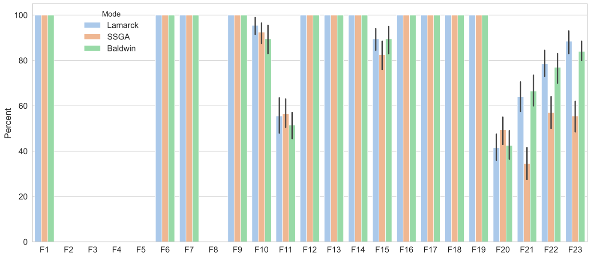

Figure Bar plots for percentage values for SSGA, Baldwin and Lamarck algorithms( threshold=0.0001)

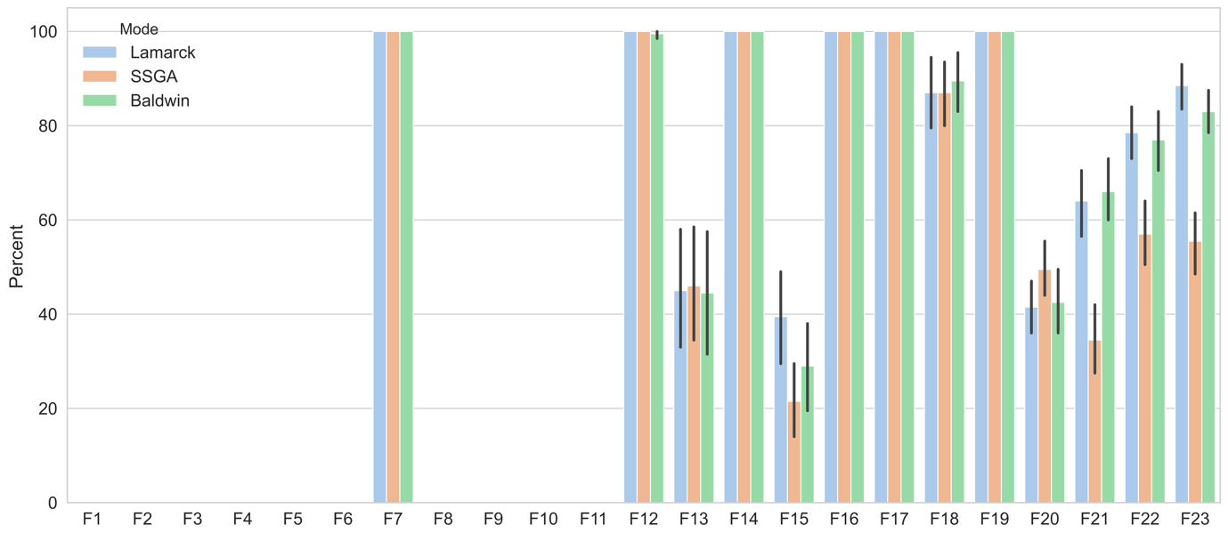

Figure 7 clearly illustrates that the differences among performance between SSGA, Baldwin and Lamarck are in the seven functions F13, F15, F18, F20, F21, F22, and F23.

The following conclusions for Figure 7 can be seriously drawn:

1. On F21, F22, and F23, the error bars of Baldwin algorithm and the error bars of SSGA do not overlap, which means that their performance in these three functions is significantly different. Or in other words, compared to SSGA, Baldwin is significantly better.
2. On F15, F21, F22, and F23, the error bars of Lamarck algorithm and the error bars of SSGA do not overlap, which means Lamarck algorithm is significantly better.

### Improvements between SSGA and Baldwin, Lamarck algorithms

Figure violin plots for comparing solutions of SSGA, Baldwin, and Lamarck algorithms

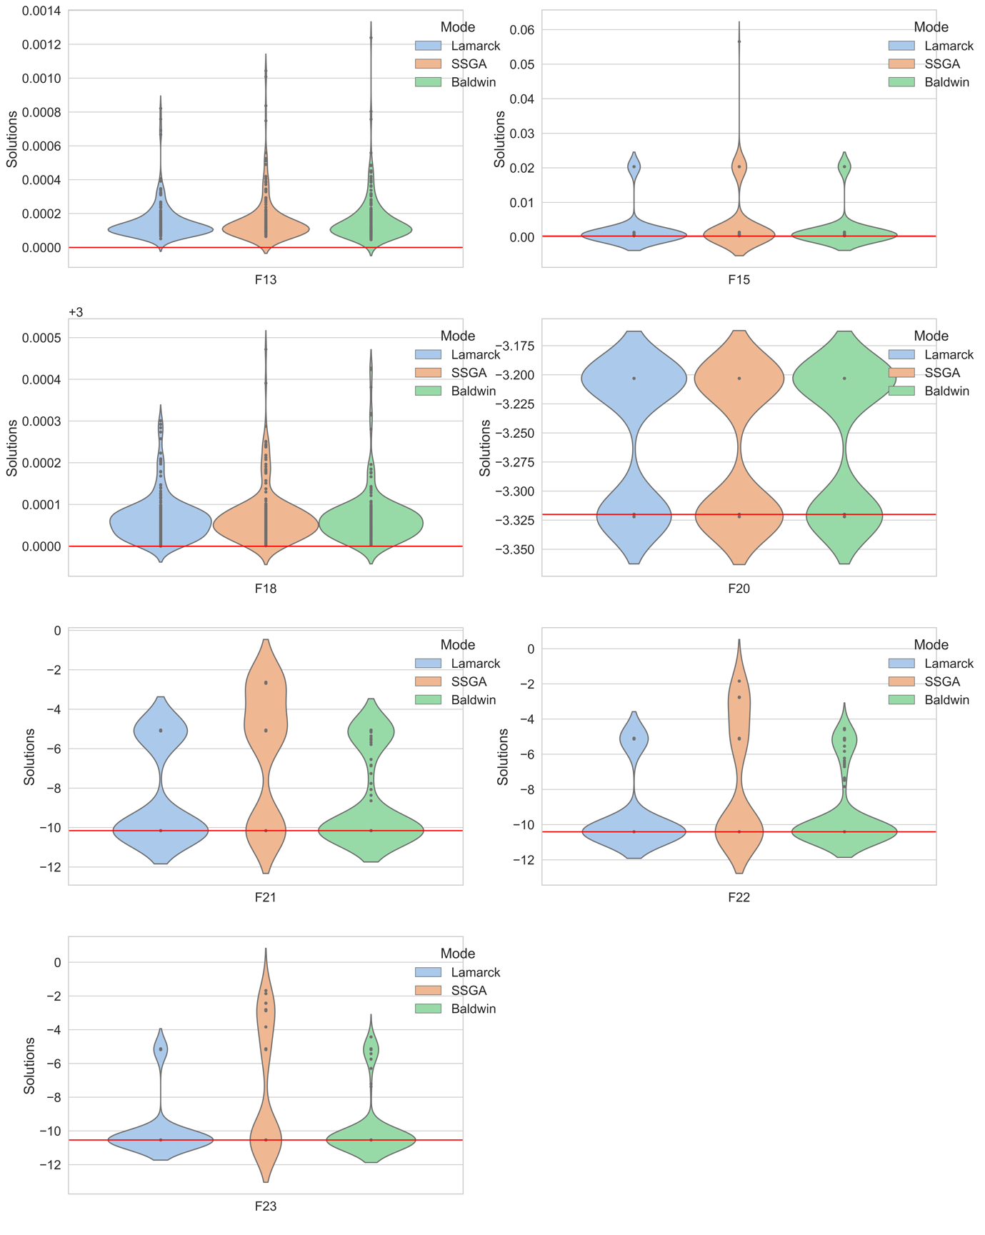

Figure 8 shows the violin plots for SSGA, Baldwin and Lamarck algorithms on F13, F15, F18, F20, F21, F22, and F23, respectively. Each subplot has a red horizontal line running through it, which represents the position of the global minimum of a function. The criterion for finding the minimum successfully is abs(solution-global minima) < 0.0001, which is the same as Figure 7. We have 20 parameter combinations. Each parameter combination was run 10 times for each function. This means that each violin is generated from 200 solutions. The black dots represent the actual solutions. The reason for not seeing so many points on Figure 8 is that many of the solutions are the same.

A violin plot is designed to provide a visual representation of the distribution of numerical data by using a kernel density estimator, which shows the high peaks in the data. The wider areas of the violin plot represent the higher probability, where many data points are gathered. The wider the area, the more data points there are. On the contrary, the thinner areas represent the lower probability and less data concentrated here.

The following conclusions can be drawn from Figure 8:

1. The global minima for F13,F18,F20 are 0,3,-3.32, respectively. From Figure 7 we see that there is no significant difference in the mean probability of finding the minimum in these three functions for the SSGA, Baldwin and Lamarck algorithms, but they do differ. Although different, the minimum values of each function they find are of the same order of magnitude, and also acceptable. Taking F18 as an example, the solutions found by all three algorithms are generally below 0.0001, and their distribution is basically identical. It is fair to conclude that Baldwin and Lamarck have not improved on these 3 functions, but they are not worse either.
2. On the 4 functions F15, F21,F22, F23, it is very obvious in Figure 8 that the Lamarck and Baldwin algorithms find lower solutions than those found by SSGA.

Now, one might be curious as to how the performance on other functions looks like. These three algorithms perform almost equally for other functions, such as F1- F6 and F8-F11, and the solutions they achieve are all in the same order of magnitude and also very similar. This will be proven in the convergence analysis coming next.

### Convergence analysis

Based on the convergence properties of the functions, we have divided the 23 functions into 3 groups. First group contains 12 functions, which are F1, F3, F4, F5, F6, F7, F8, F9, F10, F11, F12, F13. Second group consists of 7 functions, namely F2, F14, F16, F17, F18, F19, F20. The last group consists of 4 functions, i.e., F15, F21, F22, F23. Among all following convergence plots, the horizontal coordinate denotes iterations/50, the vertical coordinate denotes the fitness value of the best individual, and the yellow horizontal line specifies the position of the global optimal value. The band filled between represents that confidence interval = 95%.

Figure Convergence plots for F1

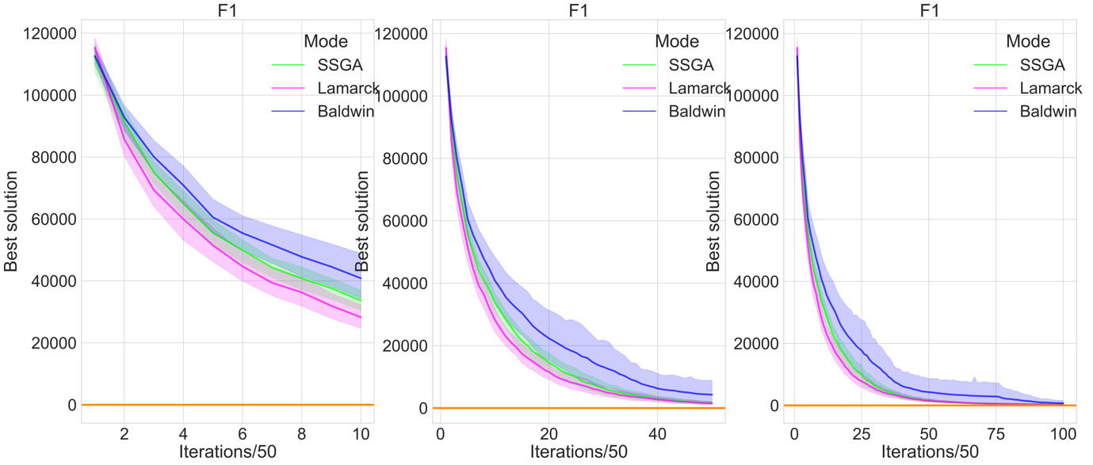

Figure Convergence plots for F3

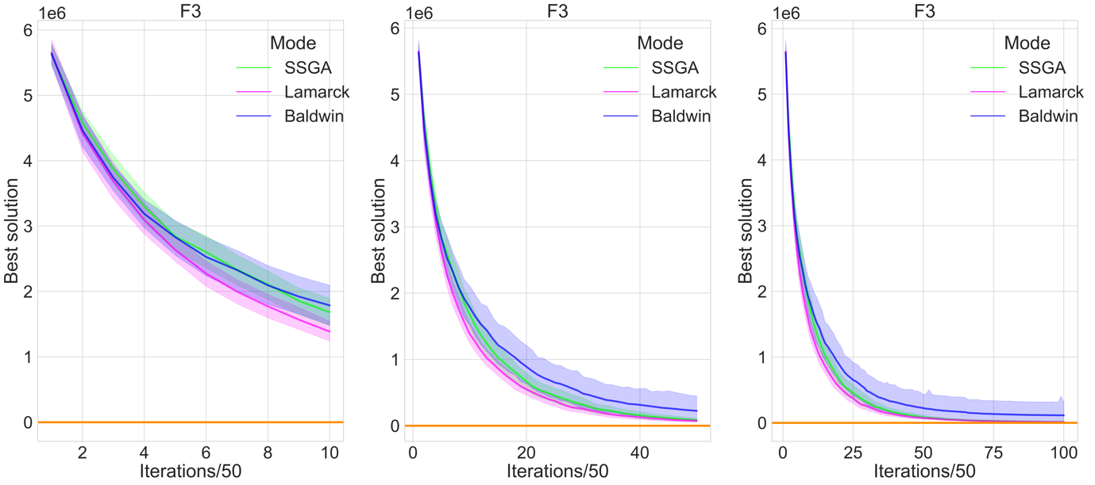

Figure Convergence plots for F4

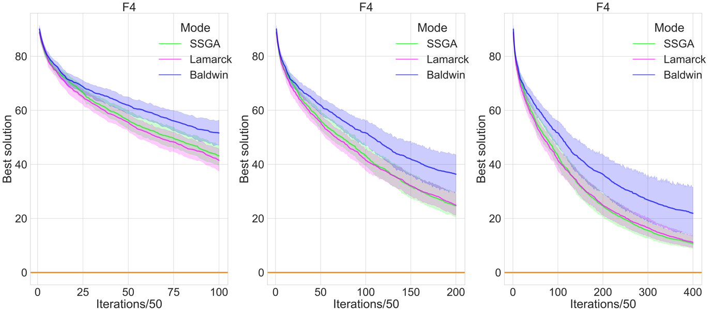

Figure Convergence plots for F5

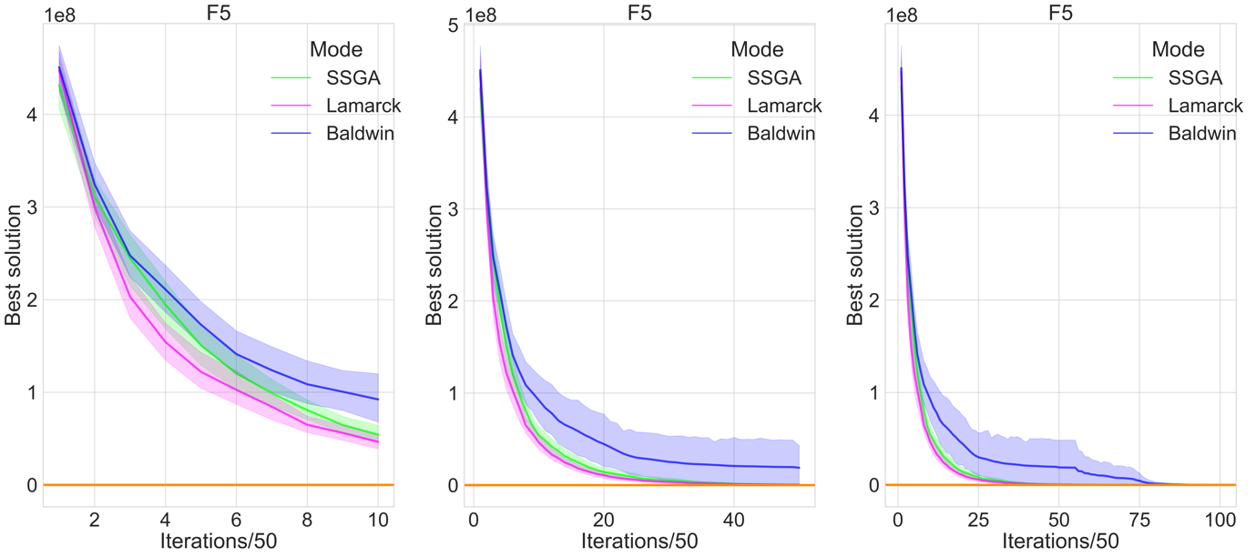

Figure Convergence plots for F6

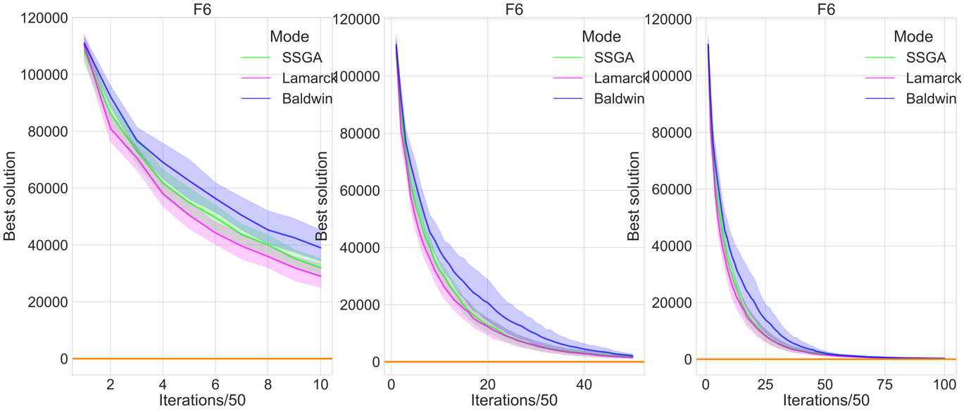

Figure Convergence plots for F7

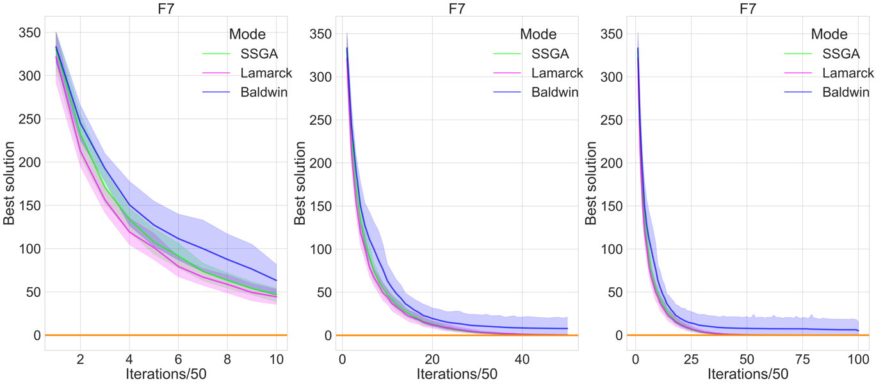

Figure 15 Convergence plots for F8

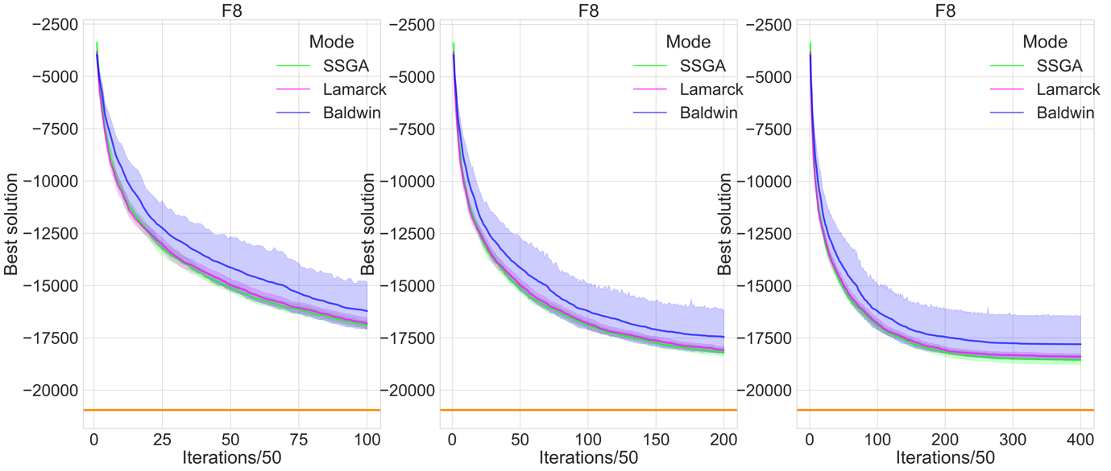

Figure Convergence plots for F9

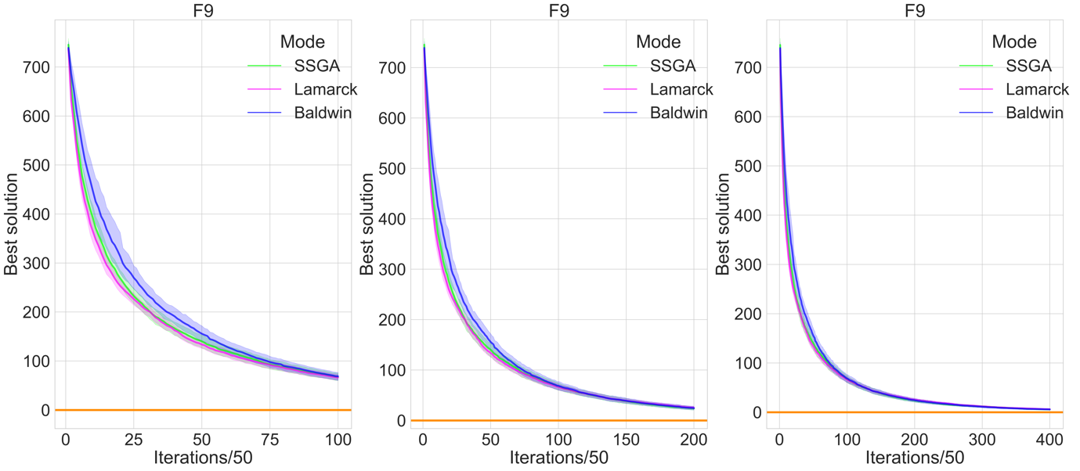

Figure Convergence plots for F10

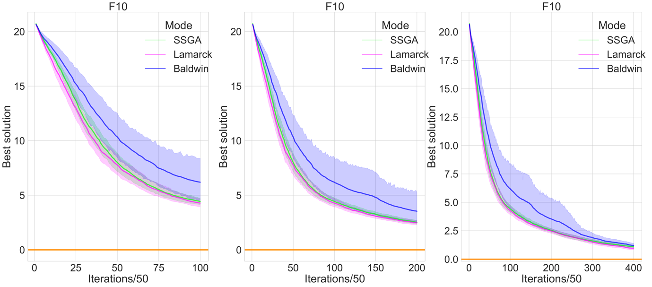

Figure Convergence plots for F11

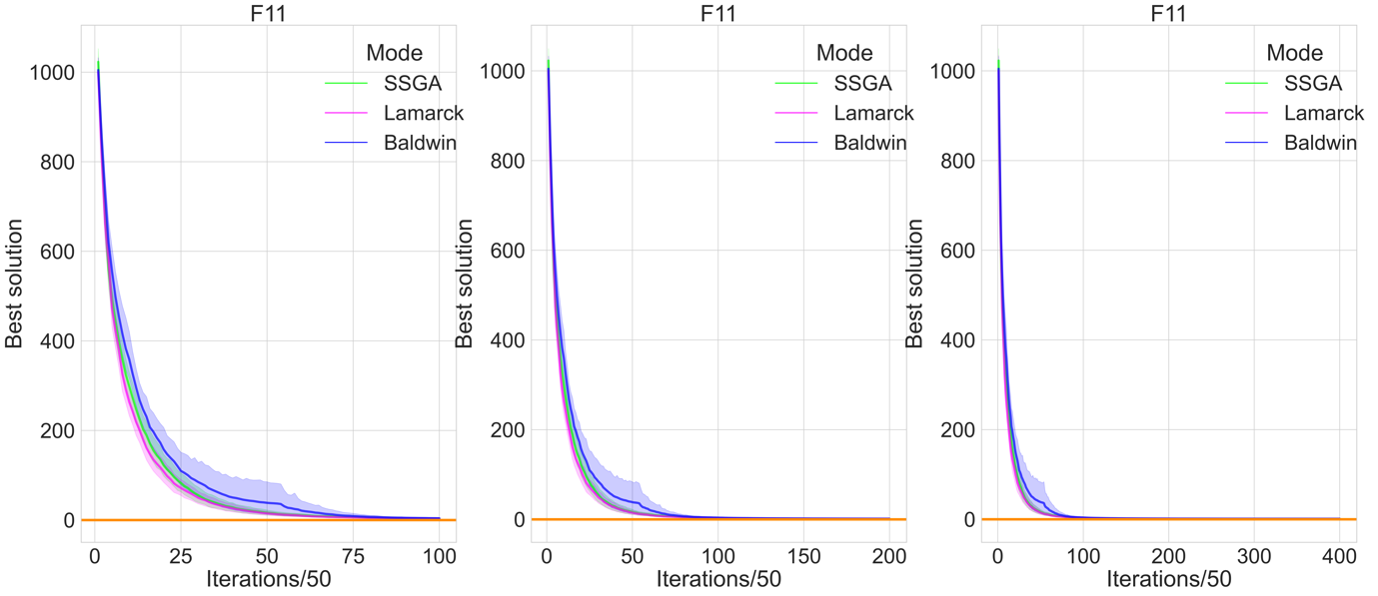

Figure Convergence plots for F12

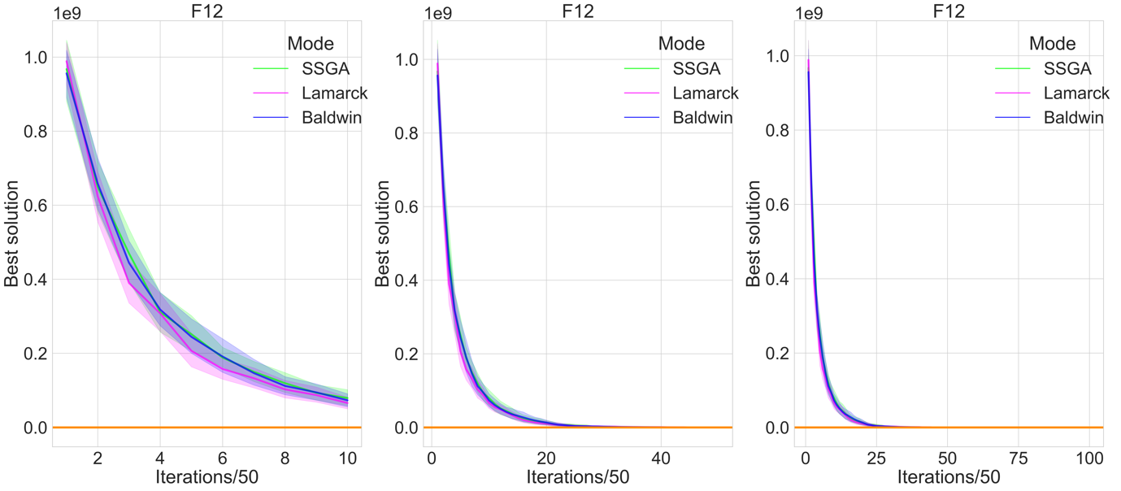

Figure Convergence plots for F13

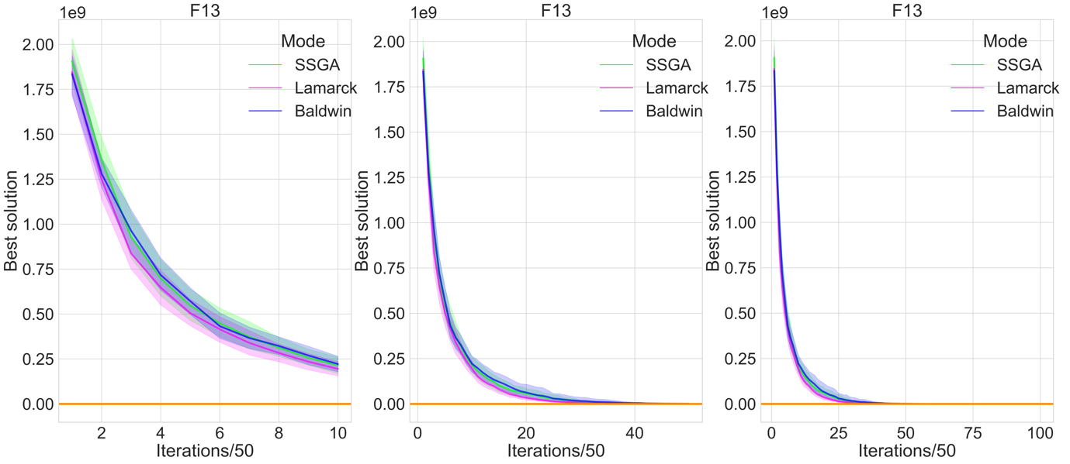

From above Figures 9-20, the following conclusion for first group can be drawn:

1. The stability of Lamarck algorithm and SSGA are comparable, which can be derived from the width of 95% confidence interval of both. However, Lamarck converges a little faster than SSGA, one can see that the position of the pink curve of Lamarck is a little lower than the position of the green curve of SSGA.
2. Both of SSGA and Lamarck algorithm converge faster and are more stable than the Baldwin algorithm. The width of 95% confidence interval of Baldwin is much wider than that of former two and the position of the blue curve of Baldwin is higher.
3. Crucially, all three algorithms are essentially able to converge to the vicinity of the global minimum of all functions in first group except for F8, they just fail to achieve an accuracy of 0.0001.
4. Ultimately, the three algorithms will converge on essentially the same level in terms of the performance of the first group of functions.

Figure Convergence plots for F2

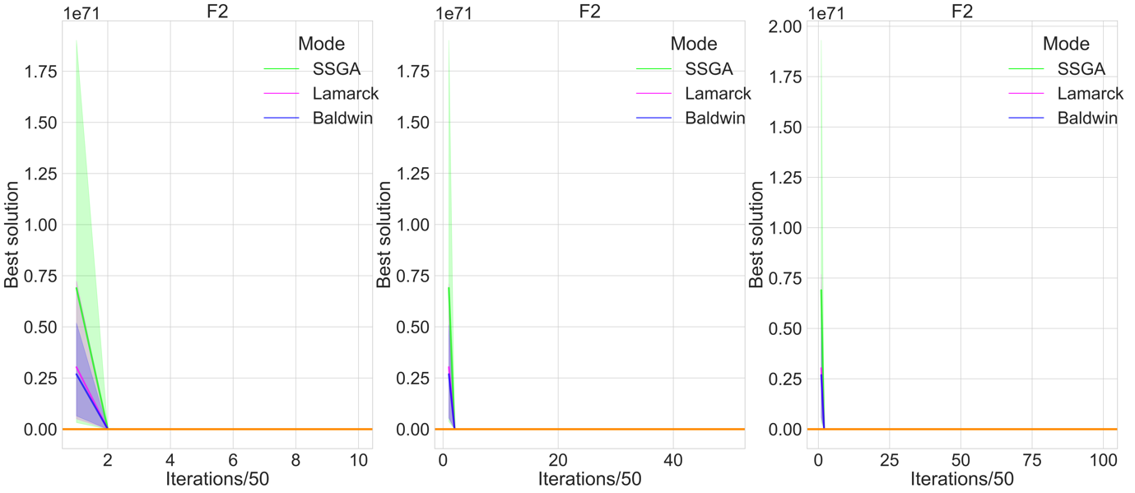

Figure Convergence plots for F14

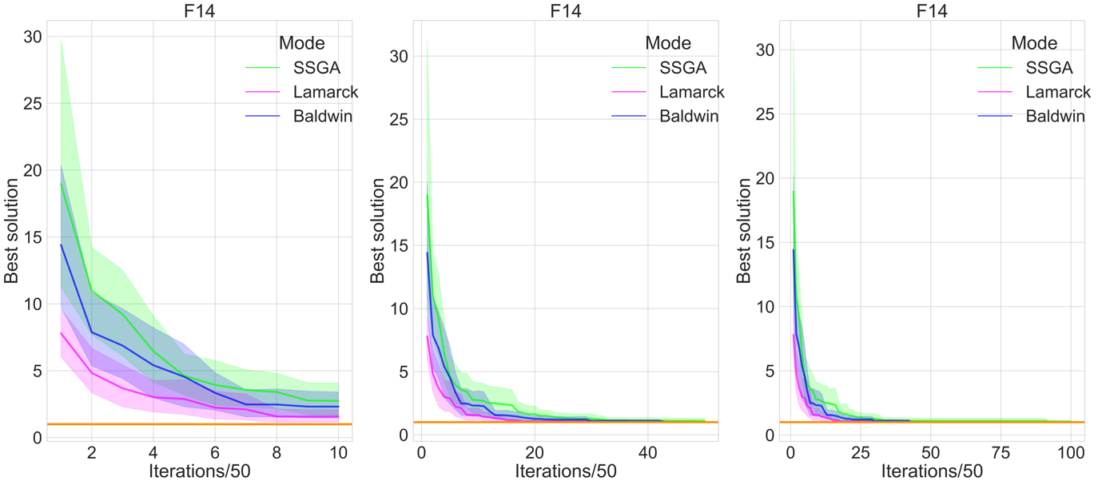

Figure Convergence plots for F16

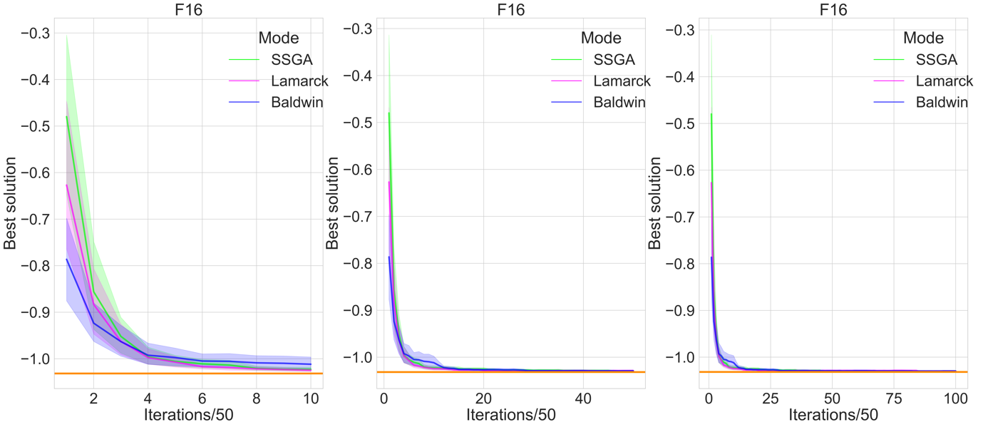

Figure Convergence plots for F17

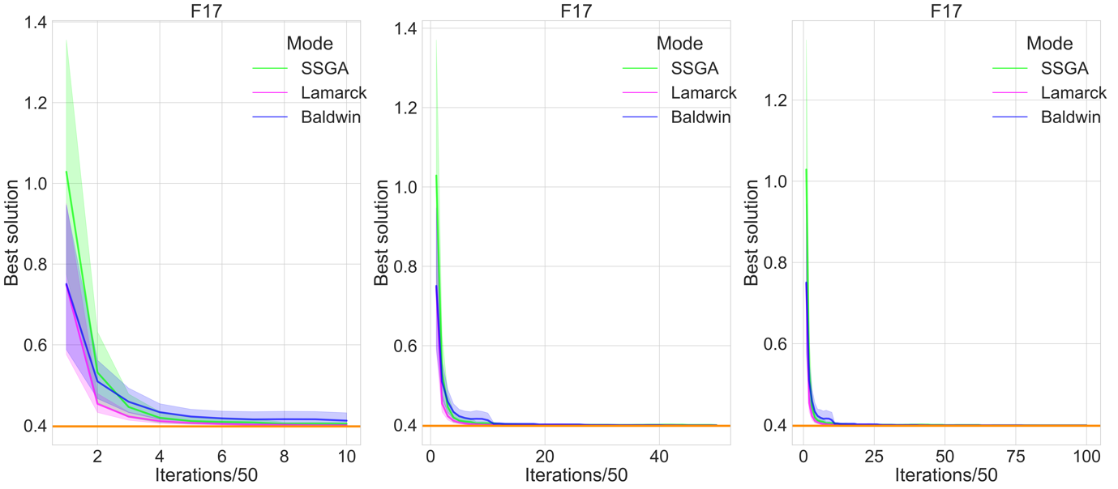

Figure Convergence plots for F18

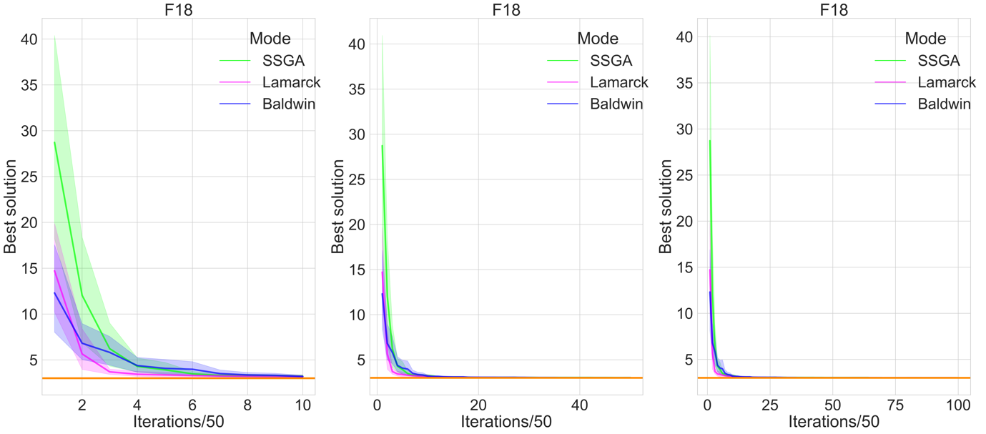

Figure Convergence plots for F19

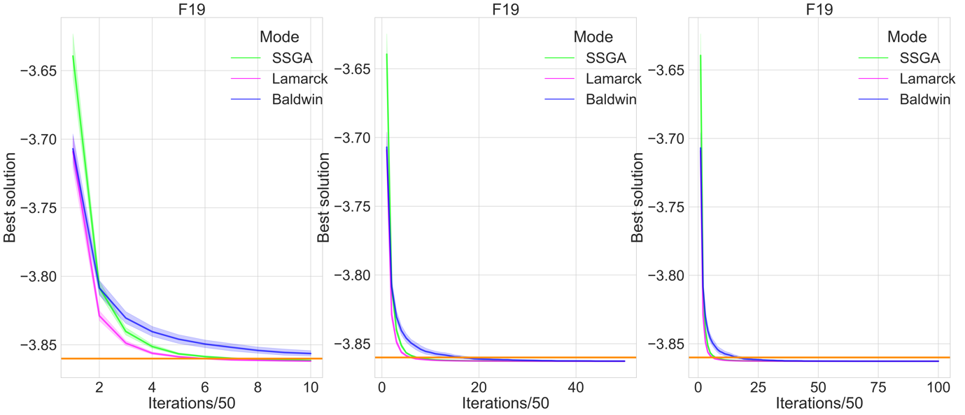

Figure Convergence plots for F20

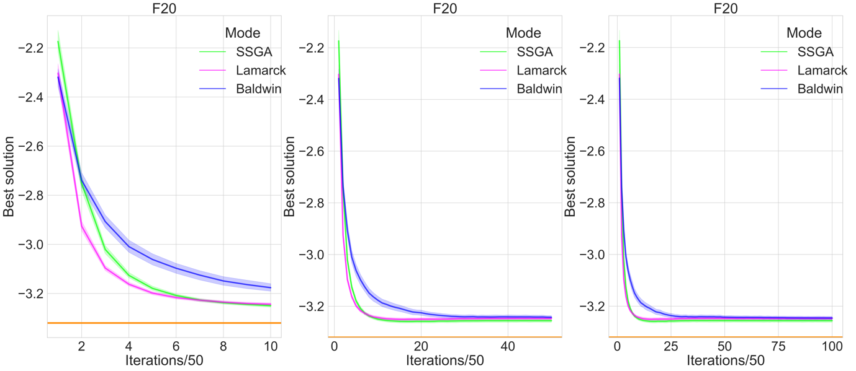

From above Figures 17-23, the following conclusion for second group can be drawn:

1. It is easy to see that Baldwin and Lamarck algorithms perform better during the initial iterations. It is obvious that the green line of the SSGA is on top during the initial iterations, which means that the solutions found by the SSGA are relatively far from the global minimum.
2. The conclusions of the first group are also applicable to the second group of functions.

The following Figures 28-31 are the convergence plots for the third group functions (F15, F21, F22, F23), these 4 functions are exactly the ones where the Baldwin and Lamarck algorithms show a significant difference compared to SSGA in the previous bar plots and violin plots. We can see that:

1. The stability of the three algorithms is similar, as the widths of the 95% confidence intervals are similar.
2. At the beginning, the Lamarck algorithm converged the fastest, with SSGA second and Baldwin third, but Baldwin quickly overtook SSGA’s position to become second. This is a situation that is not seen in other functions.

Figure Convergence plots for F15

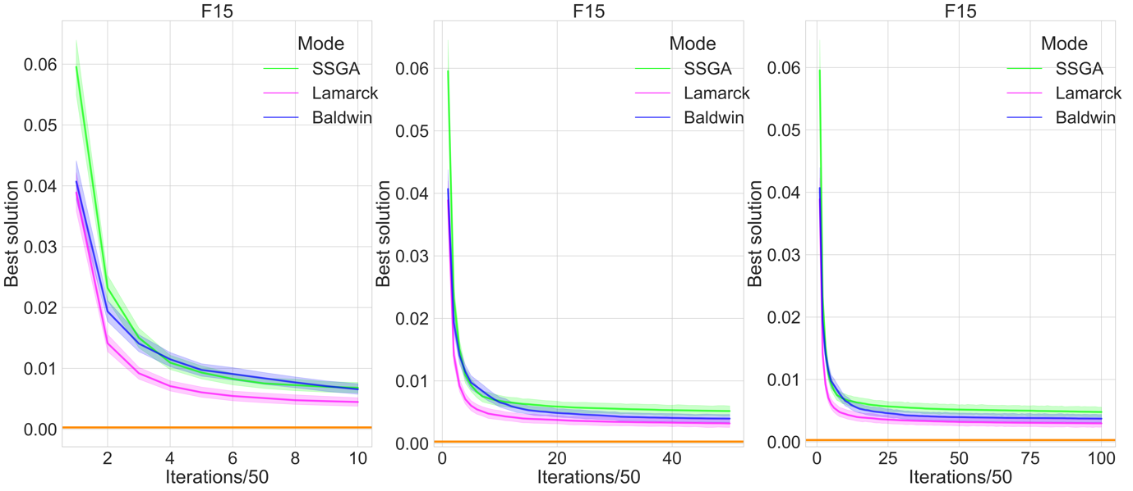

Figure Convergence plots for F21

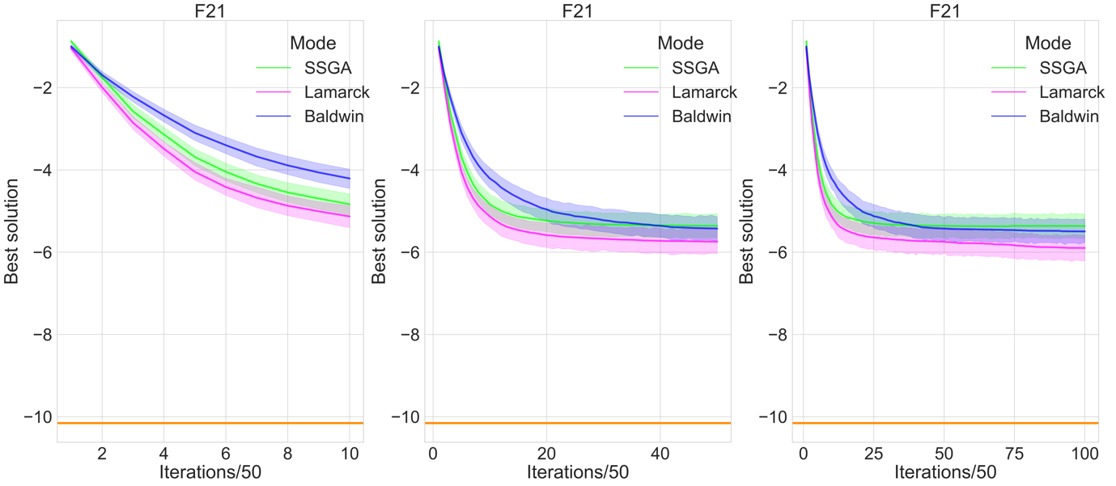

Figure Convergence plots for F22

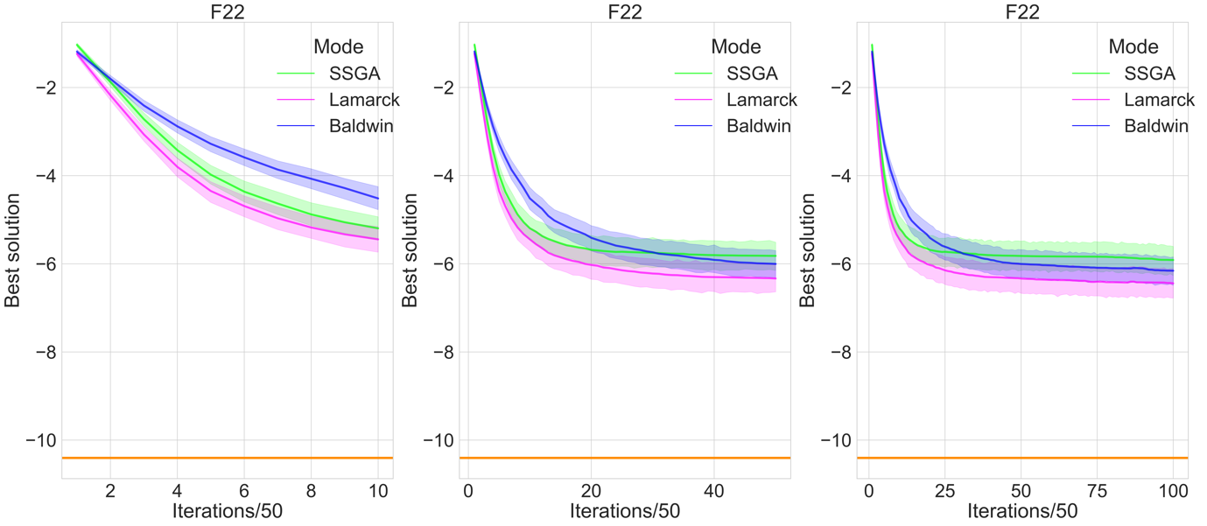

Figure Convergence plots for F23

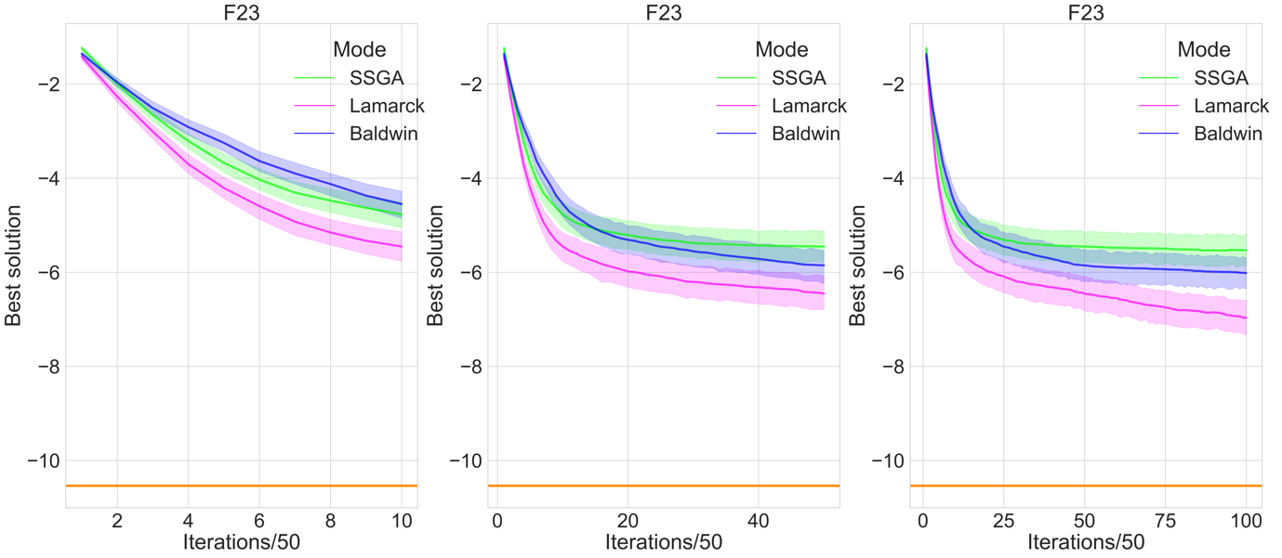

# Conclusion

The bar plots and the violin plots demonstrate the improvements made by the Baldwin and Lamarck algorithms over the SSGA, with the dominant differences found in F15, F21, F22, and F23. For the other functions, the Baldwin and Lamarck algorithms perform comparably to the SSGA. Overall, then, the Baldwin and Lamarck algorithms are better than SSGA. This means that the local search procedures of the Baldwin and Lamarck algorithms are useful to a certain level, as we expected for the first goal.

With regard to the analysis of convergence rates and results, over many functions (12 functions in first group) the three algorithms eventually converge at an equivalent level, producing solutions of the identical quality. On several functions (7 functions in second group), the Baldwin and Lamarck algorithms show apparent superiority in the preliminary iterations. In the third group of 4 functions, the stability of the three is similar, but the Lamarck and Baldwin algorithms are able to converge to a lower position, which means that the solutions they can find will be closer to the global minimum.

Our second goal is to compare the Baldwin and Lamarck algorithms. Lamarck algorithm converges faster and plays more consistently than Baldwin algorithm does. It is hard to claim that the Lamarck algorithm is definitely better than the Baldwin algorithm because no significant difference is found between the two algorithms in the long run, and fast convergence rate may be a disadvantage in some cases.

Future work may try to specify different search radius R for different functions, as proposed algorithms are actually capable of finding global optimal value of many functions, but fail to meet the high accuracy requirements, and this could theoretically help if the range of search radius R were reduced.

# Reference

1. Michalewicz, Z. (1992) *Genetic algorithms + data structures = evolution programs*. Berlin, Heidelberg: Springer Berlin Heidelberg.
2. Michalewicz, Z. and Schoenauer, M. (1996) “Evolutionary algorithms for constrained parameter optimization problems,” *Evolutionary computation*, 4(1), pp. 1–32. doi: 10.1162/evco.1996.4.1.1.
3. Mirjalili, S. (2019) “Genetic Algorithm,” in *Studies in Computational Intelligence*. Cham: Springer International Publishing, pp. 43–55.
4. Collins, R. J. and Jefferson, D. R. (1991) “Selection in Massively Parallel Genetic Algorithms,” *International Conference on Genetic Algorithms*.
5. Ishibuchi, H. and Yamamoto, T. (2004) “Fuzzy rule selection by multi-objective genetic local search algorithms and rule evaluation measures in data mining,” *Fuzzy Sets and Systems. An International Journal in Information Science and Engineering*, 141(1), pp. 59–88. doi: 10.1016/s0165-0114(03)00114-3.
6. Hutter, M. (2002) “Fitness uniform selection to preserve genetic diversity,” in *Proceedings of the 2002 Congress on Evolutionary Computation. CEC’02 (Cat. No.02TH8600)*. IEEE. doi: 10.1109/cec.2002.1007025.
7. Grefenstette, J. J. and Baker, J. E. (1989) “How Genetic Algorithms Work: A Critical Look at Implicit Parallelism,” *International Conference on Genetic Algorithms*.
8. Syswerda, G. (1989) “Uniform Crossover in Genetic Algorithms,” *International Conference on Genetic Algorithms*.
9. Semenkin, E. and Semenkina, M. (2012) “Self-configuring genetic algorithm with modified uniform crossover operator,” in *Lecture Notes in Computer Science*. Berlin, Heidelberg: Springer Berlin Heidelberg, pp. 414–421.
10. Hu, X. B. and Di Paolo, E. (2007) “An efficient Genetic Algorithm with uniform crossover for the multi-objective Airport Gate Assignment Problem,” in *2007 IEEE Congress on Evolutionary Computation*. IEEE. doi: 10.1109/cec.2007.4424454.
11. Tsutsui, S., Yamamura, M. and Higuchi, T. (1999) “Multi-parent recombination with simplex crossover in real coded genetic algorithms,” in *Proceedings of the 1st Annual Conference on Genetic and Evolutionary Computation*. Morgan Kaufmann Publishers Inc, pp. 657–664.
12. Bck, T. and Fogel, D. B. (2000) *Evolutionary computation 1: Basic algorithms and operators*. Edited by Z. Michalewicz. CRC press.
13. Oliver, I. M., Smith, D. and Holland, J. R. (1987) “Study of permutation crossover operators on the travelling salesman problem,” in Associates, L. E. (ed.) *Proceedings of the Second International Conference on Genetic Algorithms and their Applications*. Cambridge, MA. Hillsdale, NJ.
14. Davis, L. (1985) “Applying adaptive algorithms to epistatic domains,” *In IJCAI*, 85, pp. 162–164.
15. Hinterding, R. (1995) “Gaussian mutation and self-adaption for numeric genetic algorithms,” in *Proceedings of 1995 IEEE International Conference on Evolutionary Computation*. IEEE. doi: 10.1109/icec.1995.489178.
16. Tsutsui, S. and Fujimoto, Y. (1993) “Forking genetic algorithm with blocking and shrinking modes (fGA),” in *ICGA*, pp. 206–215.
17. Oosthuizen, G. D. (1987) “Supergran: A connectionist approach to learning, integrating genetic algorithms and graph induction,” in Associates, L. E. (ed.) *Proceedings of the second International Conference on Genetic Algorithms and their Applications*. Cambridge, MA. Hillsdale, NJ.
18. Mauldin, M. L. (1984) “Maintaining diversity in genetic search,” in *AAAI*, pp. 247–250.
19. Ankenbrandt, C. A. (1991) “An extension to the theory of convergence and a proof of the time complexity of genetic algorithms,” in *Foundations of Genetic Algorithms*. Elsevier, pp. 53–68.
20. Kallel, L., Naudts, B. and Reeves, C. R. (2001) “Properties of fitness functions and search landscapes,” in *Natural Computing Series*. Berlin, Heidelberg: Springer Berlin Heidelberg, pp. 175–206.
21. Van Cleve, J. and Weissman, D. B. (2015) “Measuring ruggedness in fitness landscapes,” *Proceedings of the National Academy of Sciences of the United States of America*, 112(24), pp. 7345–7346. doi: 10.1073/pnas.1507916112.
22. Dawkins, R. (1976) “The Selfish Gene,” *Evolution; international journal of organic evolution*, 32(1), p. 220. doi: 10.2307/2407425.
23. Moscato, P. (1989) *On Evolution, Search, Optimization, Genetic Algorithms and Martial Arts: Towards Memetic Algorithms*. Pasadena.
24. Krasnogor, N. (2012) “Memetic Algorithms,” in *Handbook of Natural Computing*. Berlin, Heidelberg: Springer Berlin Heidelberg, pp. 905–935.
25. Radcliffe, N. J. and Surry, P. D. (1994) “Formal memetic algorithms,” in *Evolutionary Computing*. Berlin, Heidelberg: Springer Berlin Heidelberg, pp. 1–16.
26. Garg, P. (2010) “A Comparison between Memetic algorithm and Genetic algorithm for the cryptanalysis of Simplified Data Encryption Standard algorithm,” *arXiv [cs.CR]*. Available at: http://arxiv.org/abs/1004.0574.
27. Pandey, H. M., Chaudhary, A. and Mehrotra, D. (2014) “A comparative review of approaches to prevent premature convergence in GA,” *Applied soft computing*, 24, pp. 1047–1077. doi: 10.1016/j.asoc.2014.08.025.
28. García-Martínez, C. and Lozano, M. (2007) “Local search based on genetic algorithms,” in *Natural Computing Series*. Berlin, Heidelberg: Springer Berlin Heidelberg, pp. 199–221.
29. Hinton, G. and Nowlan, S. (1987) “How learning can guide evolution,” *Complex Syst*, 1, pp. 495–502.
30. Bull, L., Holland, O. and Blackmore, S. (2000) “On meme-gene coevolution,” *Artif Life*, 6, pp. 227–235.
31. Houck, C. R. *et al.* (1997) “Empirical investigation of the benefits of partial Lamarckianism,” *Evolutionary computation*, 5(1), pp. 31–60. doi: 10.1162/evco.1997.5.1.31.
32. Mayley, G. (1996) “Landscapes, learning costs, and genetic assimilation,” *Evolutionary computation*, 4(3), pp. 213–234. doi: 10.1162/evco.1996.4.3.213.
33. Turney, P. (1996) “How to shift bias: Lessons from the Baldwin effect,” *Evolutionary computation*, 4(3), pp. 271–295. doi: 10.1162/evco.1996.4.3.271.
34. Whitley, D., Gordon, V. S. and Mathias, K. (1994) “Lamarckian evolution, the Baldwin effect and function optimization,” in *Parallel Problem Solving from Nature — PPSN III*. Berlin, Heidelberg: Springer Berlin Heidelberg, pp. 5–15.
35. Gruau, F. and Whitley, D. (1993) “Adding learning to the cellular development of neural networks: Evolution and the Baldwin effect,” *Evolutionary computation*, 1(3), pp. 213–233. doi: 10.1162/evco.1993.1.3.213.
36. Turney, P. D. (2002) “Myths and legends of the Baldwin effect,” *arXiv [cs.LG]*. Available at: http://arxiv.org/abs/cs/0212036.
37. Houck, C. &., Joines, J. &. and Kay, M. (1996) *Utilizing Lamarckian Evolution and the Baldwin Effect in Hybrid Genetic Algorithms*.
38. Bereta, M. (2019) “Baldwin effect and Lamarckian evolution in a memetic algorithm for Euclidean Steiner tree problem,” *Memetic computing*, 11(1), pp. 35–52. doi: 10.1007/s12293-018-0256-7.
39. Ishibuchi, H., Kaige, S. and Narukawa, K. (2005) “Comparison between Lamarckian and baldwinian repair on multiobjective 0/1 knapsack problems,” in *Lecture Notes in Computer Science*. Berlin, Heidelberg: Springer Berlin Heidelberg, pp. 370–385.
40. Paenke, I., Jin, Y. and Branke, J. (2009) “Balancing population- and individual-level adaptation in changing environments,” *Adaptive behavior*, 17(2), pp. 153–174. doi: 10.1177/1059712309103566.
41. Paenke, I. *et al.* (2007) “On the adaptive disadvantage of lamarckianism in rapidly changing environments,” in *Advances in Artificial Life*. Berlin, Heidelberg: Springer Berlin Heidelberg, pp. 355–364.
42. Ong, Y. S. and Keane, A. J. (2004) “Meta-Lamarckian learning in memetic algorithms,” *IEEE transactions on evolutionary computation : a publication of the IEEE Neural Networks Council*, 8(2), pp. 99–110. doi: 10.1109/tevc.2003.819944.
43. Faramarzi, A. *et al.* (2020) “Marine Predators Algorithm: A nature-inspired metaheuristic,” *Expert systems with applications*, 152(113377), p. 113377. doi: 10.1016/j.eswa.2020.113377.
44. Cumming, G., Fidler, F. and Vaux, D. L. (2007) “Error bars in experimental biology,” *The journal of cell biology*, 177(1), pp. 7–11. doi: 10.1083/jcb.200611141.
45. Austin, P. C. and Hux, J. E. (2002) “A brief note on overlapping confidence intervals,” *Journal of vascular surgery*, 36(1), pp. 194–195. doi: 10.1067/mva.2002.125015.